# Brief

I have been tasked with making a quiz program. The program will get its questions from an Api hosted on an open-source trivia website called [opentdb](http://opentdb.com/). I will have to turn the non-human readable format returned by the api into human a human readable and interactable program. The stakeholder has specified some requirements for the program.

I’m required to use complex programming techniques to develop this computer program. I will be using a combination of advanced techniques including making classes and objects and saving/reading data from files.

Program making requirements:

* Defining class/classes and creating objects.
* Reading from files.
* Robust error checking.
* Comment code and appropriate variable names.
* Evidence of debugging and error checking.
* Flexible and robust.
* Object oriented Classes.
* Multidimensional arrays.
* Module(s).
* Strings, Numbers and Boolean data types.

Program usage requirements:

* Topic and difficulty selection.
* User selected question amount.
* Randomize questions from file.
* Randomize answers to correct always being bottom.
* File nonexistent error checking.
* Display results at end of quiz.
* Handle multiple users.

# Plan

My program will start with a main menu, it will then have submenus:

* Play quiz
* User manager
* Saves
* Setting?

The play quiz menu will contain some quick play options which will use a local file containing questions. There will also be an option allowing the user to pick category, difficulty, type and amount for a custom quiz.

The user menu will show basic user data. There will be options for new user, delete user and show advanced.

It would be cool to implement saves at some time allowing the player to save the quiz for a later date.

Automatic generation of all required files and file paths.

Automatic replenishing of local questions.

# Logs

## Version 1

I started by making the automatic file opening and generation as it’s the start of the program.

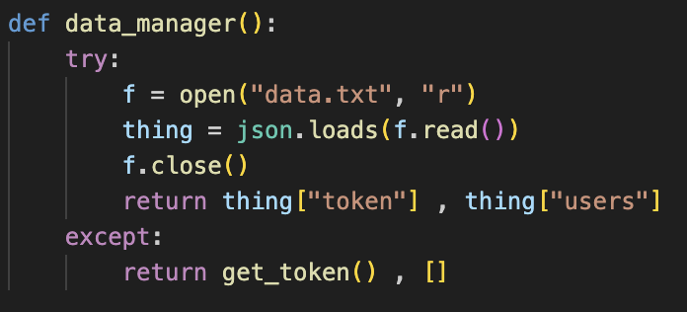

This function runs at the start of the program. It tries to read from the data file, if it can’t read from the file It will return a new token from this function. It requests a new token from the api then either returns the token or prints an error.

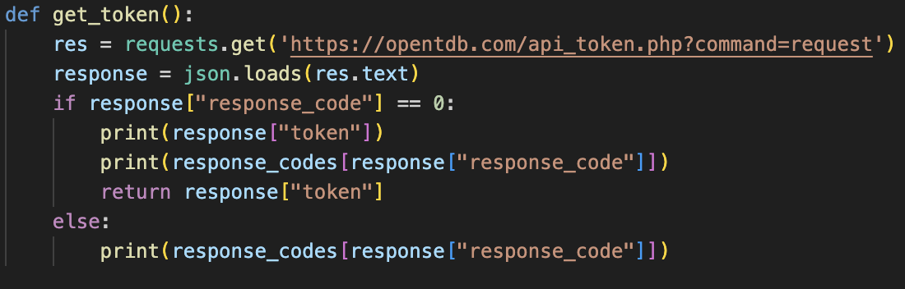

and an empty array for the users if there was no data file.

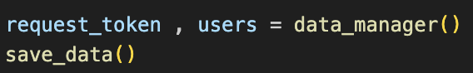

These returned values are then saved using the save data function.

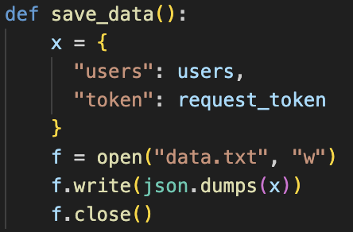

It formats the users and token as a dictionary then writes it to the data file.

The token and users are then printed as a test.

When the file exists, the program prints the token and the array.



When the file doesn’t exist, the program prints the Newley requested token, and its response code. Then the loaded data is printed.

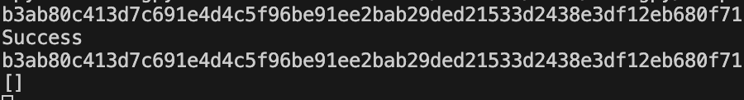

## Version 2

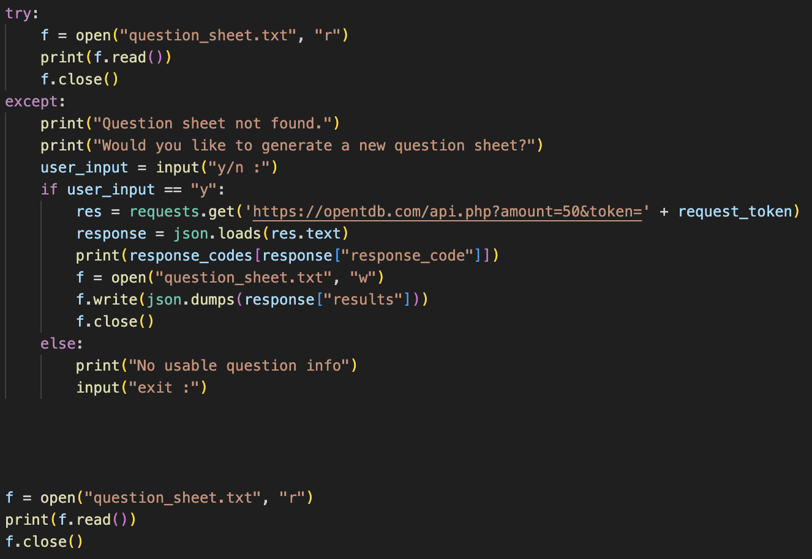

After the data file is opened the questions, file is opened. If it can’t open the user is asked if they would like a new file generated, if yes 50 random questions will be requested from the api, these questions will be written to the file. Then with subsequent program runs the questions file should open.

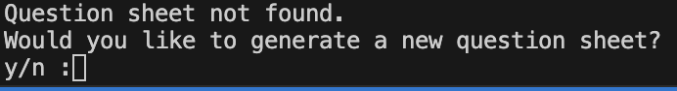

Question file not found.

## Version 3

The previous versions manual question file generation was scrapped as it was too clunky.

I made a function to request custom questions. You must specify amount and token, but you can also specify category, difficulty and type.

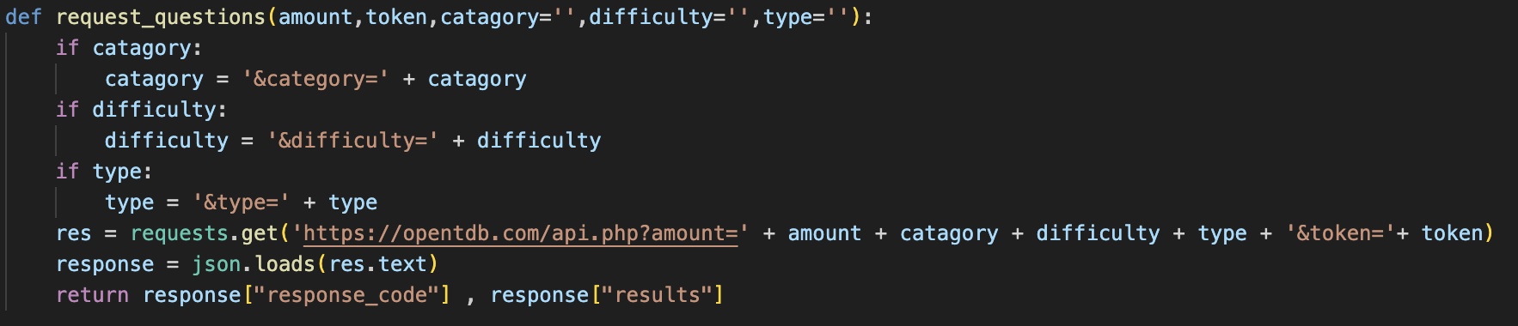

I requested 50 questions.

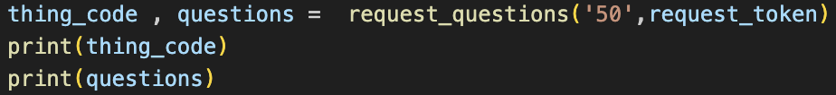

And I got the correct response.

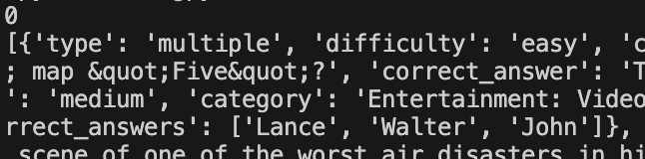

I started to implement multiuser management stuff but it doesn’t work yet. A new user and delete user function.

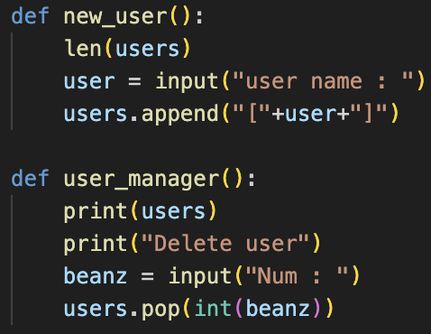

## Version 4

I started to implement a proper user system. Make an array that will hold the active arrays.

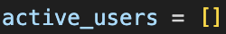

Bug

In the previous version the new user function appended a name in an array, it was meant to just append the name, this was fixed in this version.

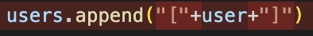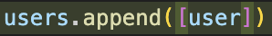

A list print function was made.

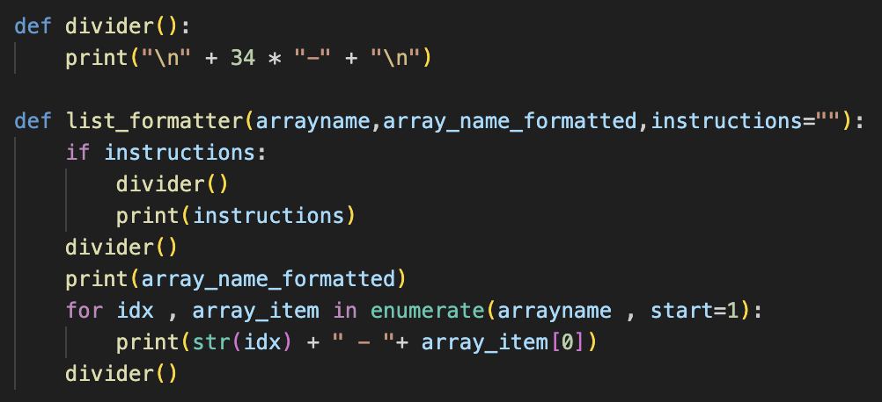

You give it a title, array and optionally instructions and it prints it in a neat format with index numbers for user choice.

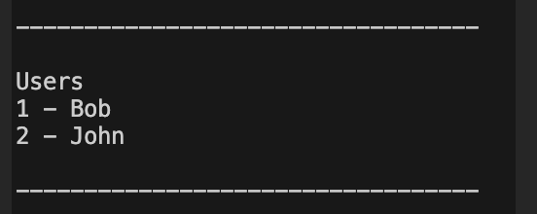

List formatter example

An active user function was also made you tell it how many players then pick from existing users.

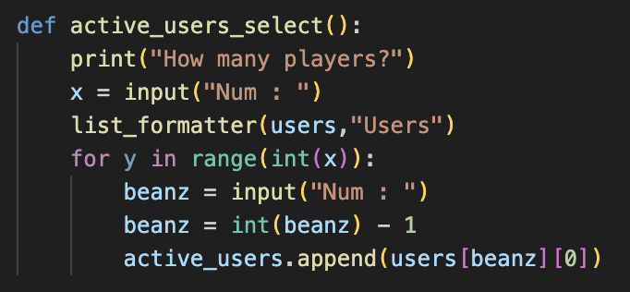

They display like this, and return an array of chosen names.

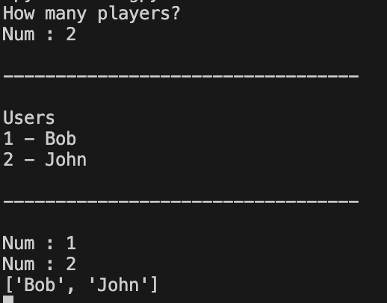

## Version 5 Bug

I tried requesting questions with a specific token, it didn’t work.

## 

It gave me a TypeError.

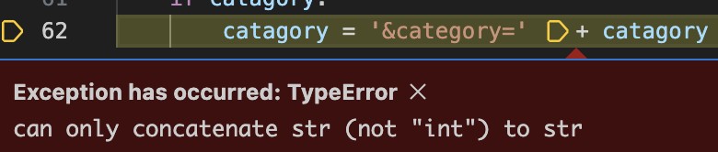

This was easily fixed by putting string around category.

Old:



New:



With this fix implemented the question request worked.

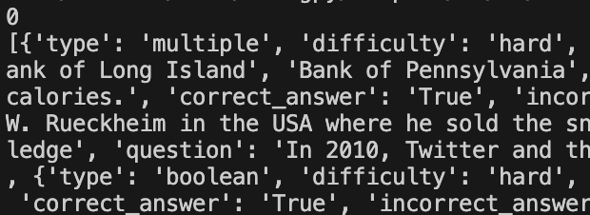

## Version 6

Nothing

## Version 7

Utility function to clear terminal, required import os.

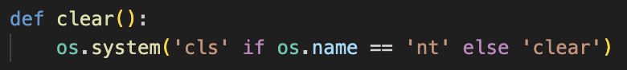

Combines the incorrect and correct answers then randomizes them. Then returns the choices and the question.

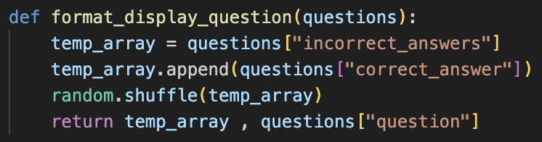

Gives array of chosen amount of random numbers within a range. Used to randomize questions gotten from file.

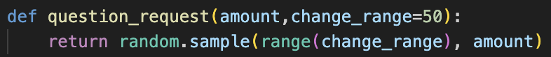

Main question loop. You give it the number of questions you want. It gets an array of randomized numbers to get questions from the file. It then goes through each question displaying it and allowing input, It also shows correct or incorrect. Multi user and score still need implementing.

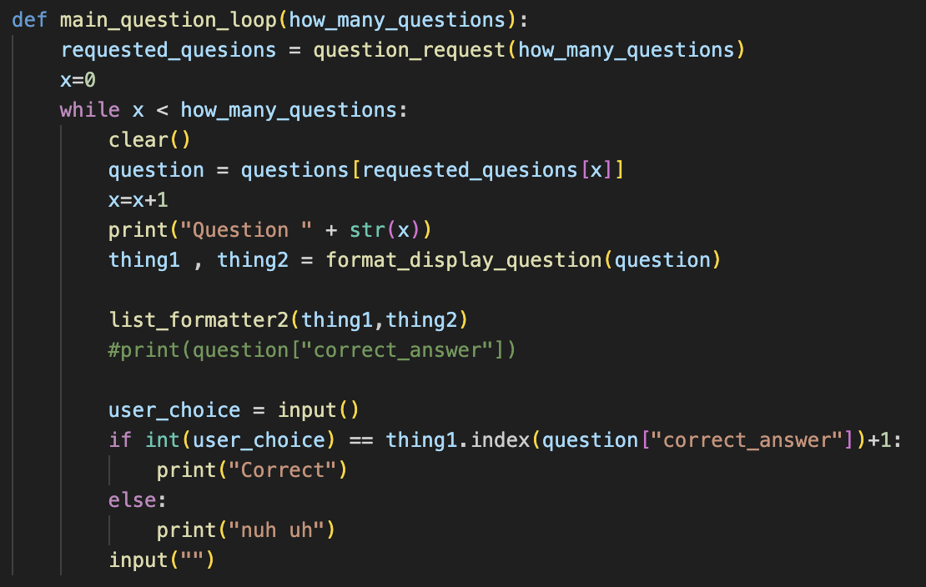

Proof of working-ness.

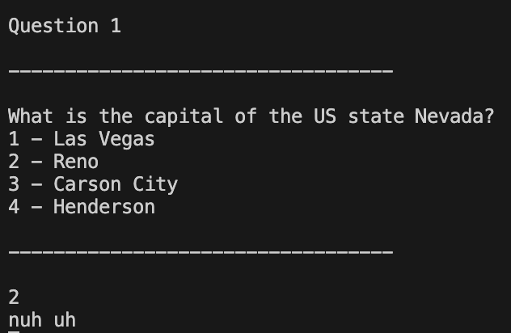

## Version 7

I rearranged the main question loop to include multiple users. It does each question for each user and it works. The active user select function is required to run before the quiz to have users in the user array.

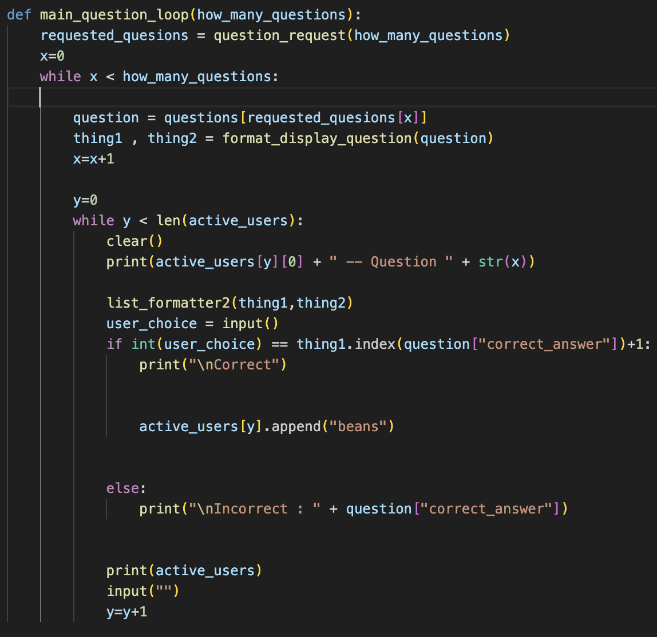

Both users got the question and could answer it. Scoring still doesn’t exist.

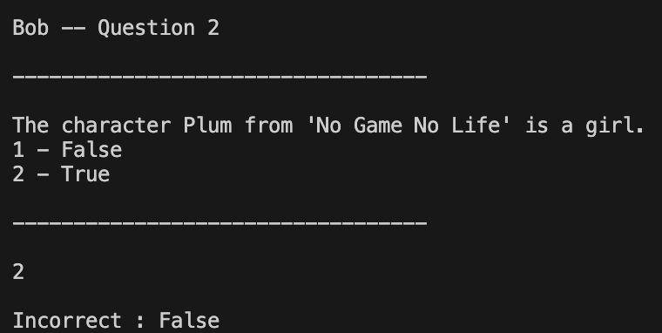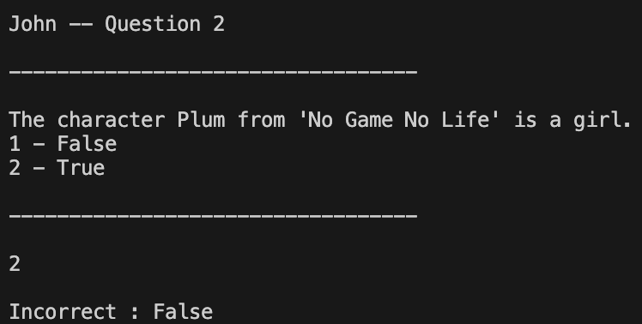

If you get it wrong, it tells you what the correct answer was now.

## Version 8

Each user is now an array with 2 integers instead of just a name. The first is correct and the second is incorrect.

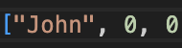

When the player gets a question correct or incorrect it will add one to the corresponding value.



The quiz also displays the scores before every new question.

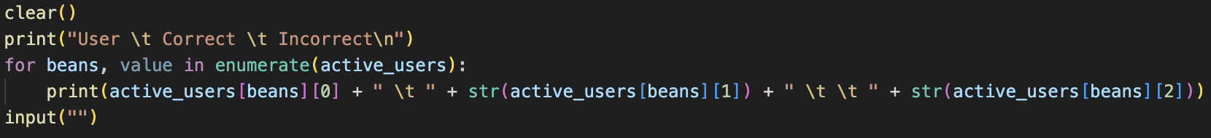

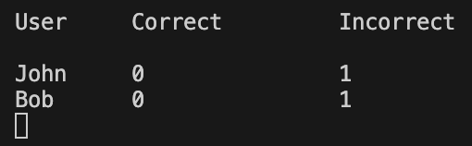

## Version 9

New user management menu.

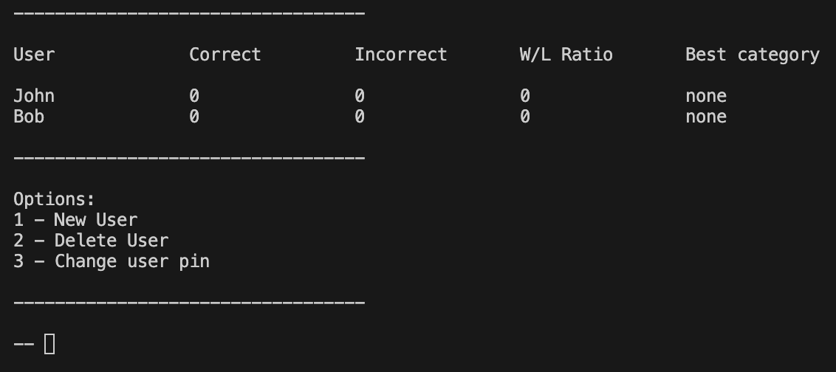

New user format, corresponds to titles in menu.

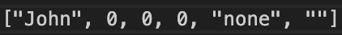

Can now easily make new users and delete users, user pins will be added later.

## Version 9

User pin menu and functionality implemented and working.

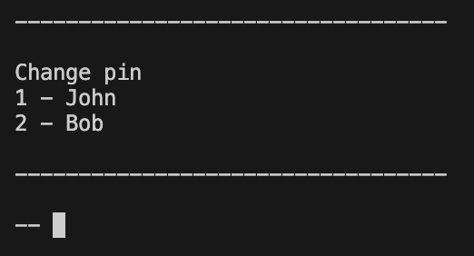

Functions re shuffled to be in order.

Main menu made.

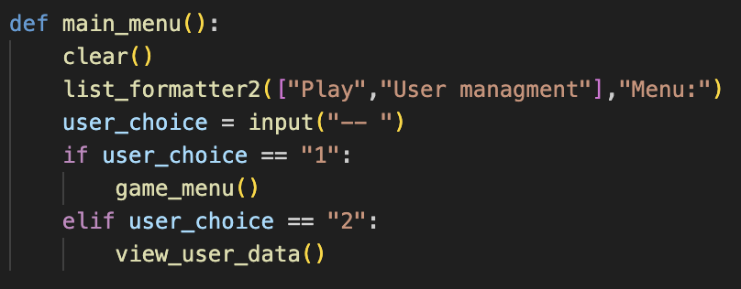

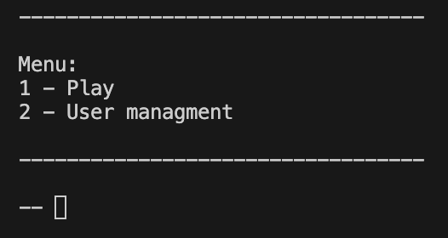

And game menu made.

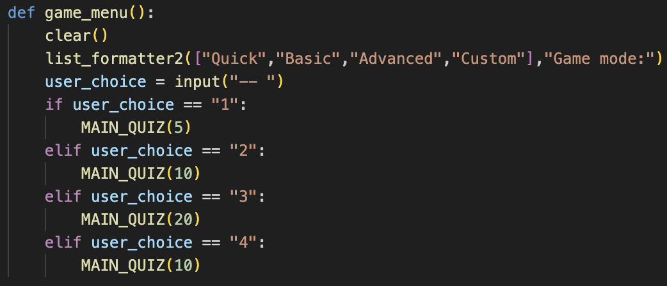

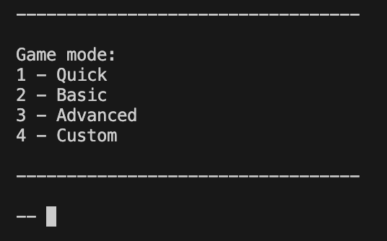

Each game mode is just a different number of questions. Custom will allow the user to pick category, difficulty, etc.

## Version 10

I made a function that gets new questions.

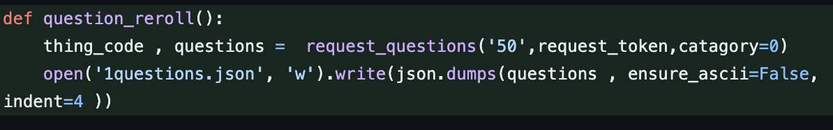

I then tested if it worked by putting it in the game menu.

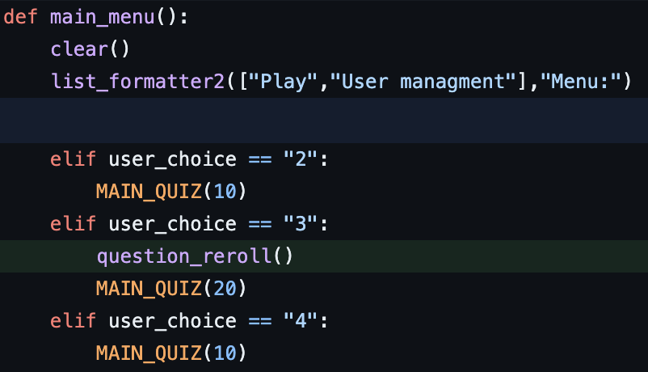

## Version 11

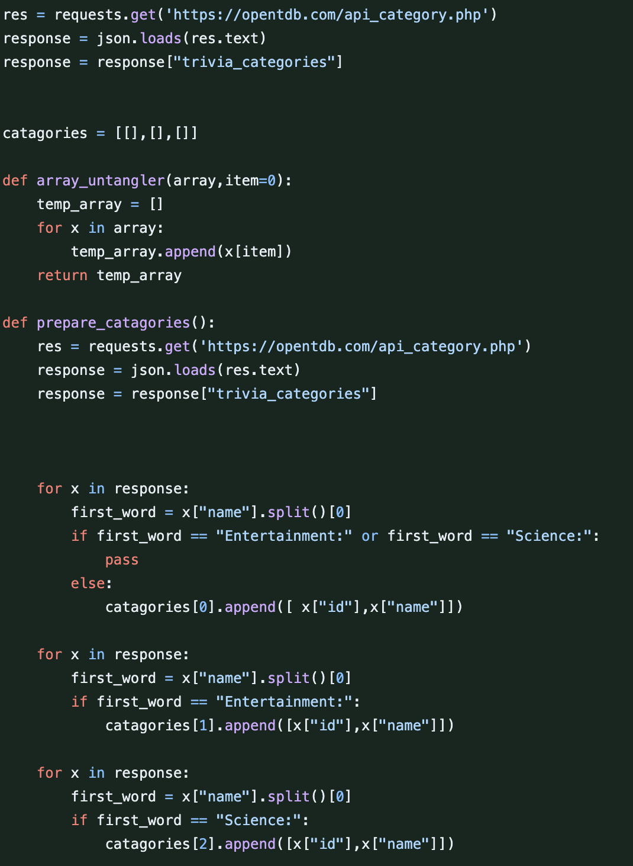

I get the categories from the api then sort them by type for use in the advanced game menu.

New advanced game user menu allows user to pick specific catagories.

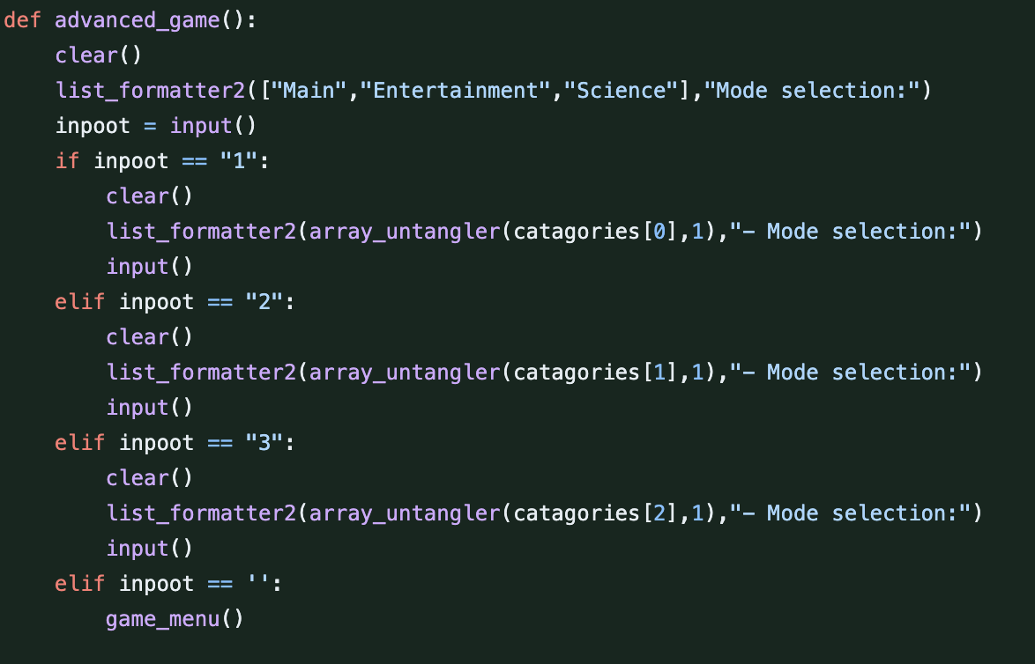

Menu:

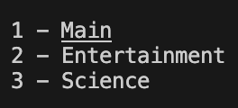

## Version 12

Get category’s runs once then saves to the data file. It then doesn’t need to be run again.

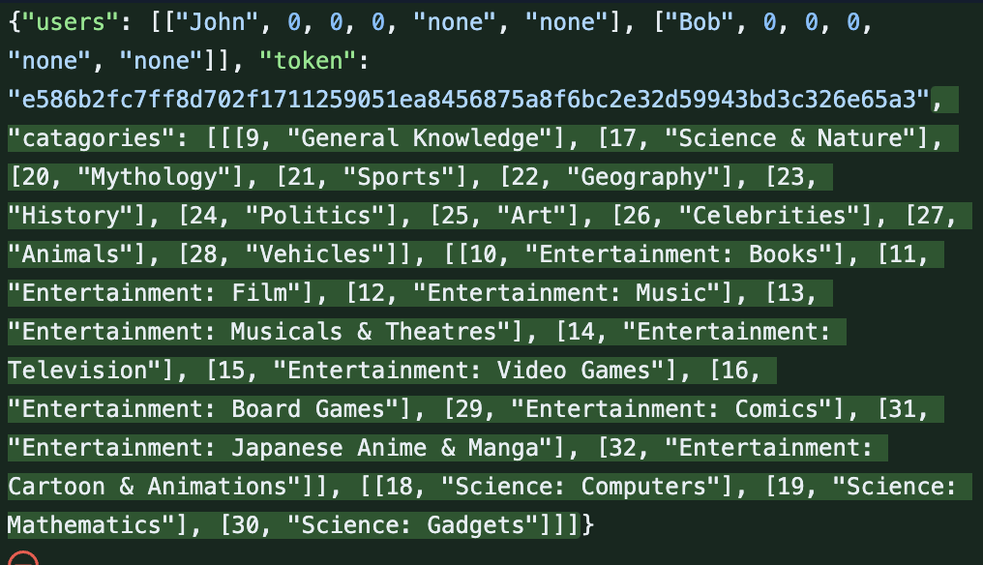

## Version 13

Depreciated the question reroll function.

Added difficulty and type options to advanced game.

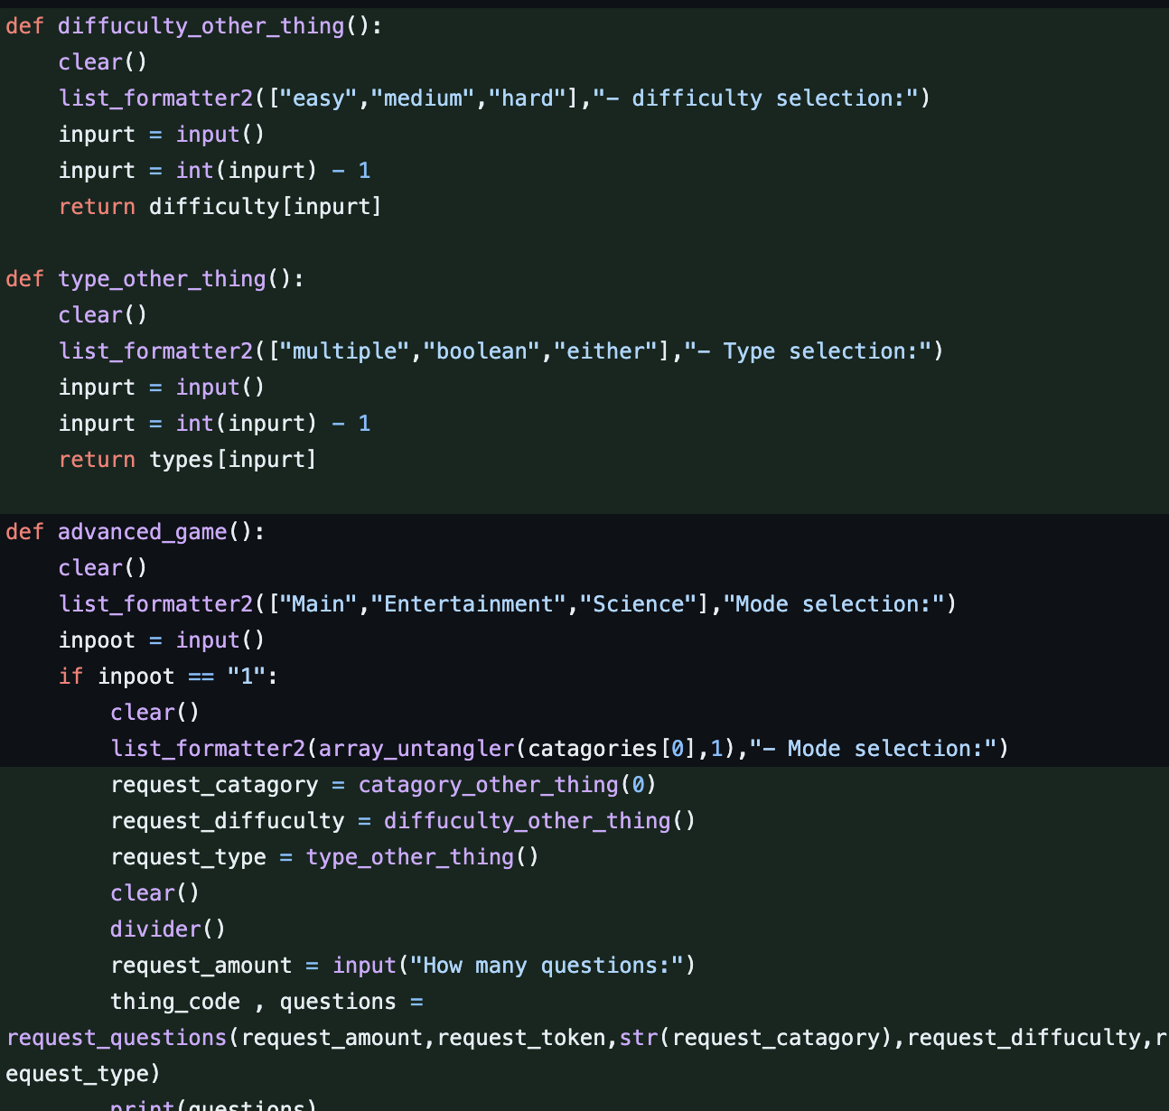

## Version 14

Bug

When making a new file It got mad that there was no array for the categories, fixed it by adding another empty array.

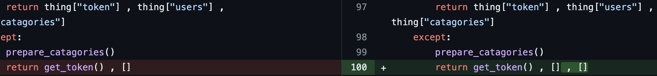

## Version 15

Minor fixes

## Version 16

Moved token to end as I’m not using it now and the parsed category id would be where token went.

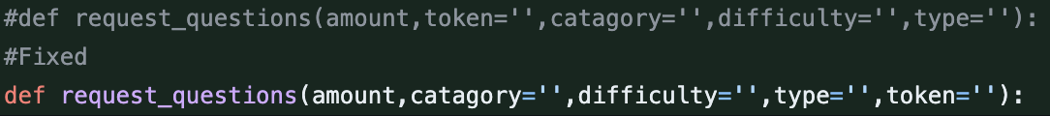

Can now choose either type instead of just one or the other

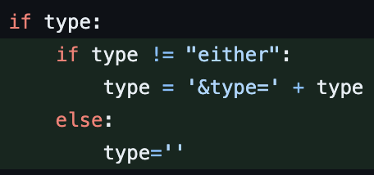

## Version 17

Input function for advanced game menu.

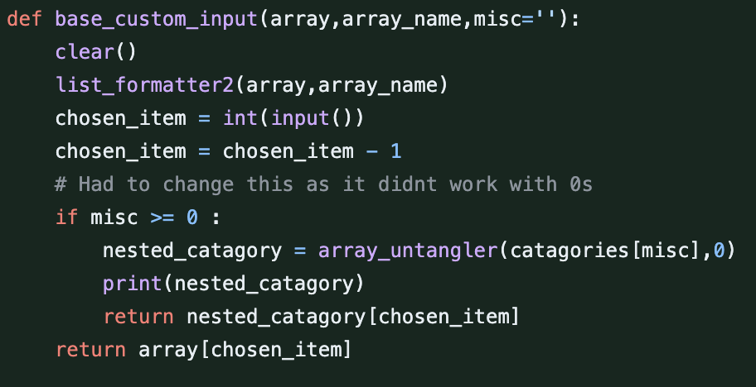

Implementation of advanced game menu input function.

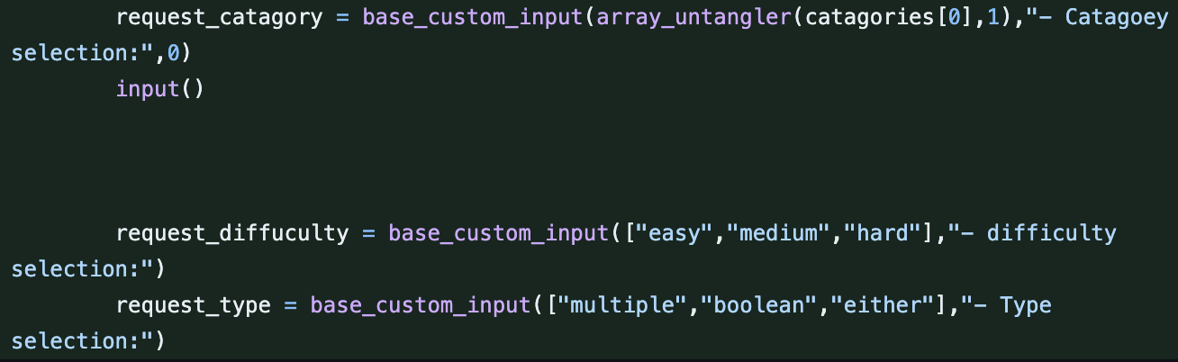

## Version 18

Cleaned up advanced game menu functions.

## Version 19

Minor changes

## Version 20

All automatic function were moved to a new file to test their function. If no data file is present, it will automatically get and sort categories. make a file then save the respective data to that file.

## [Version 0.16.1](https://github.com/Puskalincer/yr13_python/commit/b8c39216d30c250c5d22e3199c7fdadb3e91a664)

Previous automatic start test moved from separate file to main file.

## [Version 0.16.2](https://github.com/Puskalincer/yr13_python/commit/7e99702a9c8b83538a22e79bfa5917ee10432b82)

Added ability to choose any difficulty.

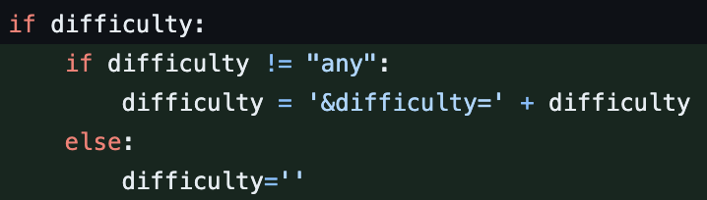

## [Version 0.16.3](https://github.com/Puskalincer/yr13_python/commit/b8c39216d30c250c5d22e3199c7fdadb3e91a664)

Turn html encoded string into readable text.



## [Version 0.17](https://github.com/Puskalincer/yr13_python/commit/8466a78df03fa0e0ded8968d355cccf2123c9868)

Testing new input function, will replace all inputs in code to stop out of bounds entries.

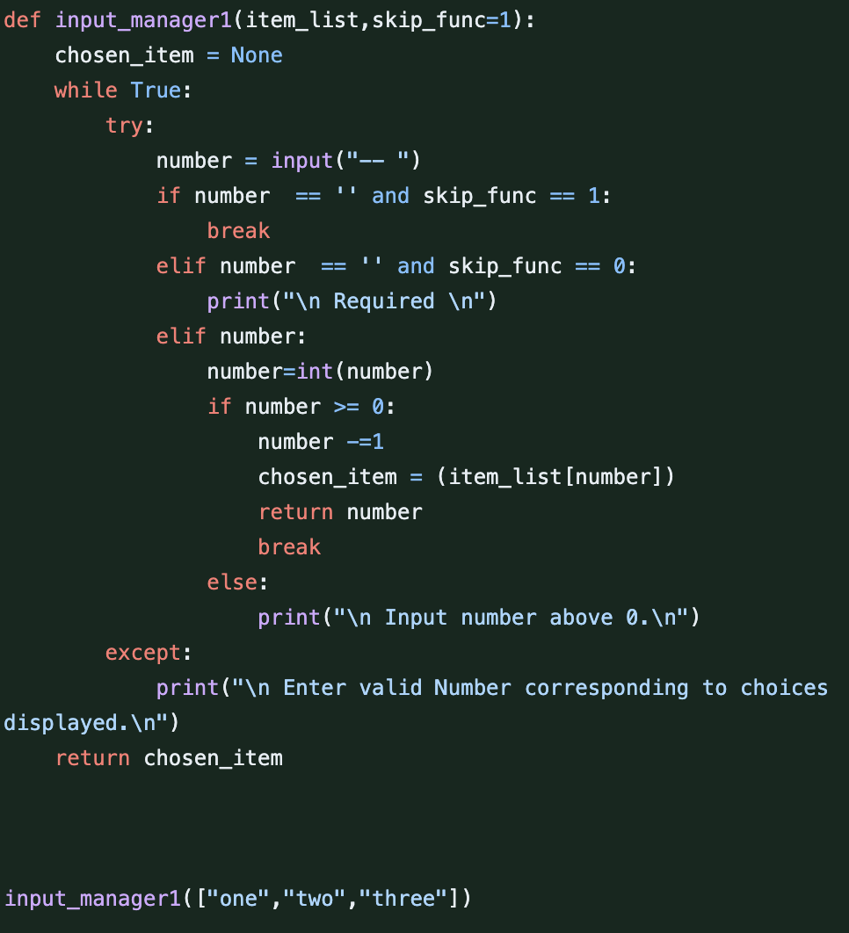

It works in range.

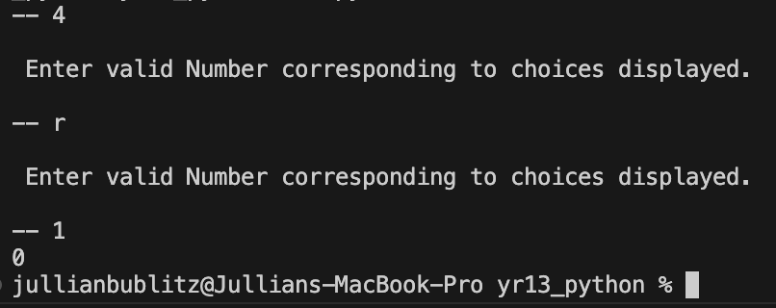

## [Version 0.17.1](https://github.com/Puskalincer/yr13_python/commit/0f48b68e3daf7a336773b3afa76f80b896a6900b)

Implement previously made input manager on main menu.



## [Version 0.17.2](https://github.com/Puskalincer/yr13_python/commit/6aee84288949bc042d7676276f9cda808b8bb24a)

Implement previously made input manager on game menu.

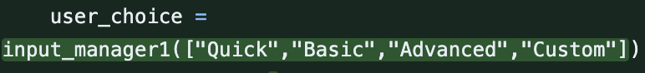

## [Version 0.18](https://github.com/Puskalincer/yr13_python/commit/cbb3fb8ebc3f81b7baa42d855ce680a18ca5fb2ehttps:/github.com/Puskalincer/yr13_python/commit/cbb3fb8ebc3f81b7baa42d855ce680a18ca5fb2e)

Put all the save data in a class.

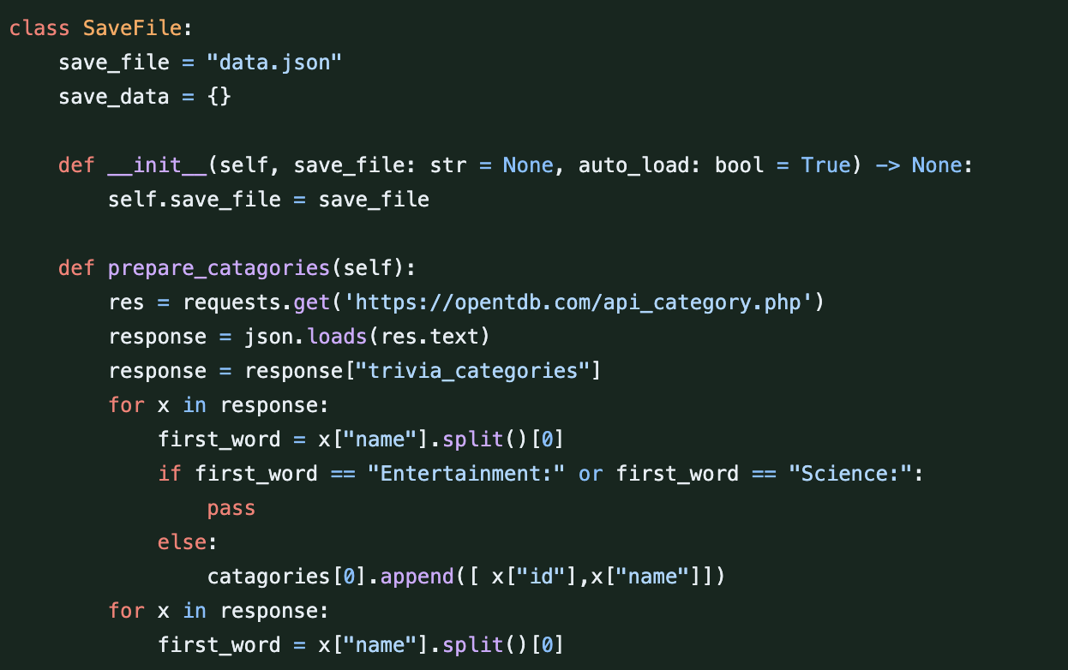

Some little gremlin tagged my work.

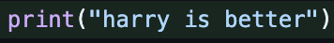

## [Version 0.18.1](https://github.com/Puskalincer/yr13_python/commit/57bf5459b337cc9f6bf1614654afb051dc431678)

Replaced list formatter with updated list formatter 2.

## [Version 0.18.2](https://github.com/Puskalincer/yr13_python/commit/b6a9d893dca88a0e6fe55401ef72cb57f14ccaf8)

Moved utility’s and api utilities to separate files.

## [Version 0.19](https://github.com/Puskalincer/yr13_python/commit/e2e56d389a81b21542a051d9a56138a2bbedb773)

All quiz preparation stuff is now in its own function. Was made to introduce save functionality. Will also be used for auto offline detection removing certain features.

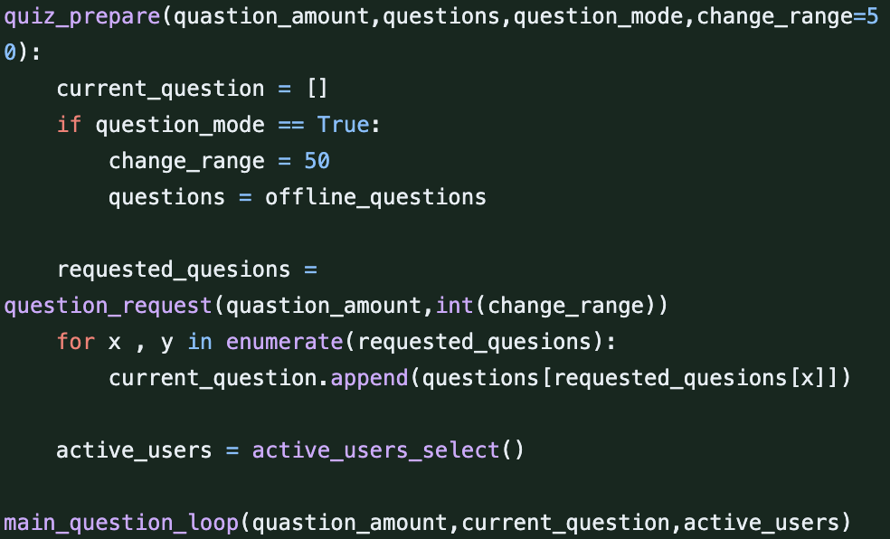

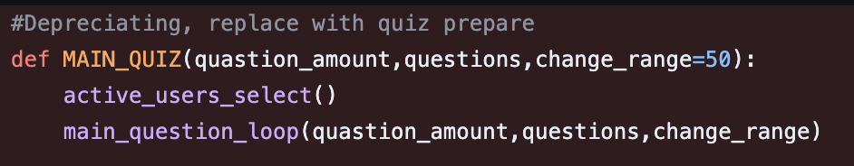

## [Version 0.19.1](https://github.com/Puskalincer/yr13_python/commit/712e4d7450701875968a534d02679e3a9e5694d7)

Bug

Tried using a module called eel to make a web based gui, sadly it doesn’t work on the latest python version. I did some internet research and found that it’s a known issue that hasn’t been solved fully yet.

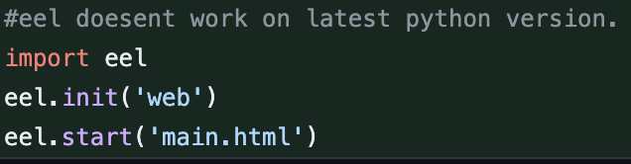

So instead I used a module called nice gui to make a nicer ui than the terminal.

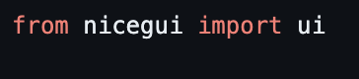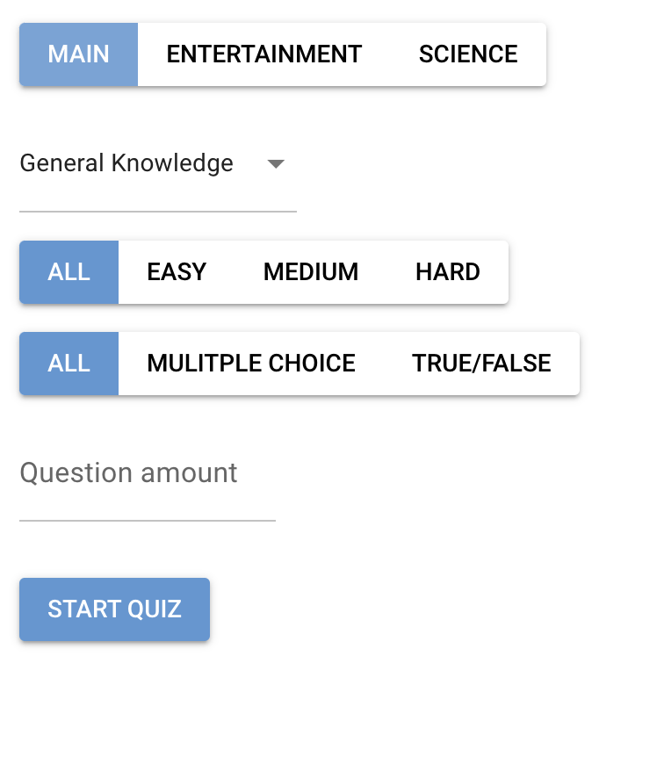

## [Version 0.19.2](https://github.com/Puskalincer/yr13_python/commit/41224ec9e288e0ba1480eea6b9108d472c12f762)

The category the user requests is now sent to the api, I then reply’s with how many questions are for each difficulty in that category.

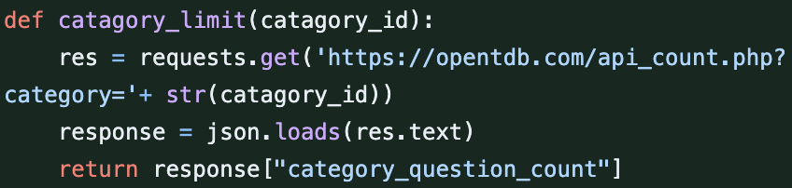

Api response.



If advanced games api request doesn’t return success print failed then return to menu, this stops the main quiz from breaking.

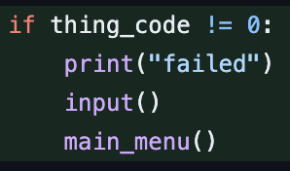

I added a counter to the questions file. Every time the program runs, it counts then at a set value it gets new questions and make the counter 0.

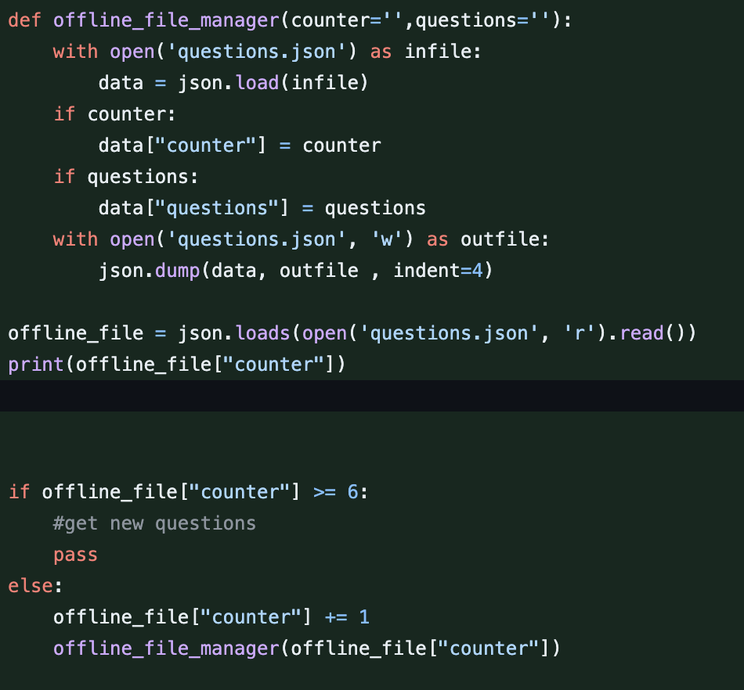

## [Version 0.20](https://github.com/Puskalincer/yr13_python/commit/80657d16914de6f1a68060543706a0ad6d540e3d)

Properly implemented the custom question limit function from last version. It shows the upper limit when it asks for question amount.

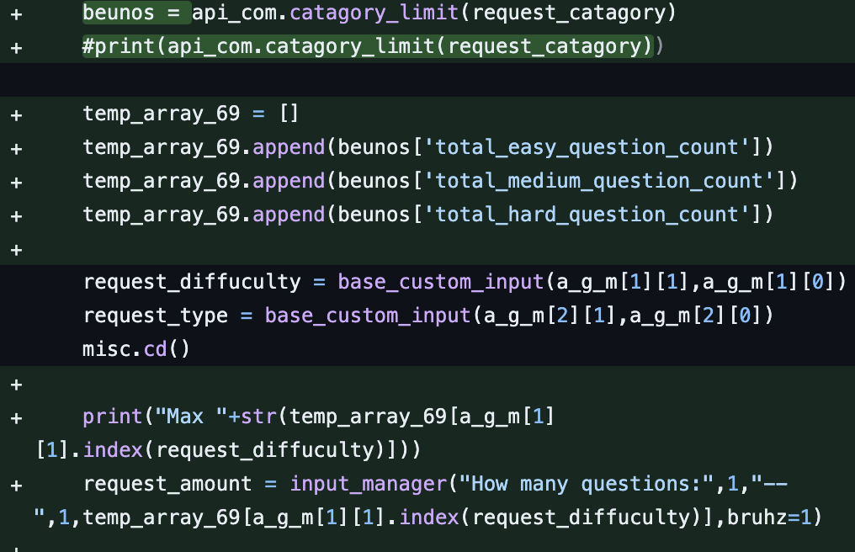

Made the local question counter generate new questions as that wasn’t implemented last version.

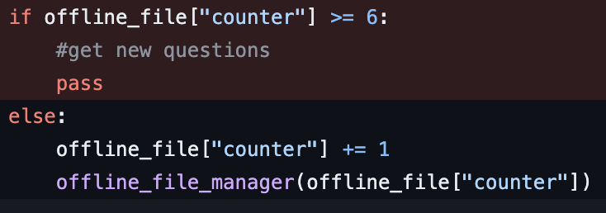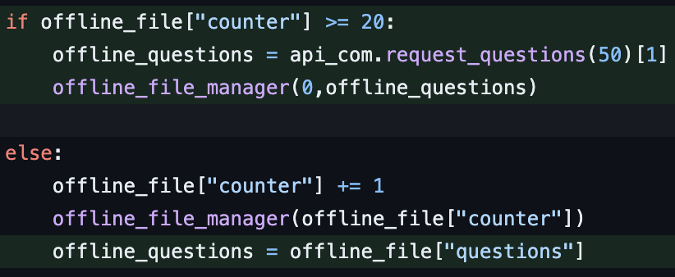

## [Version 0.20 – sockets are weird](https://github.com/Puskalincer/yr13_python/commit/5dcfbcfd0be19fee1d1424af48510a67bb59e5da)

I found an example of socket connection using python and made a basic server and client. The client just receives questions. If time allows, I’ll try make the quiz network multiplayer.

## [Version 0.20.1](https://github.com/Puskalincer/yr13_python/commit/de46bf2749faf9736c2fbdc4dcc8d6155634b5af)

Nothing notable

## [Version 0.20.2](https://github.com/Puskalincer/yr13_python/commit/10d10bd73fc23d401ff4ea18ec6fddff9363d17e)

Nothing notable

## [Version 0.21](https://github.com/Puskalincer/yr13_python/commit/f24cb191f7968fe3c431cb0ee1357e14ff68727a)

You can now save the quiz your currently playing.

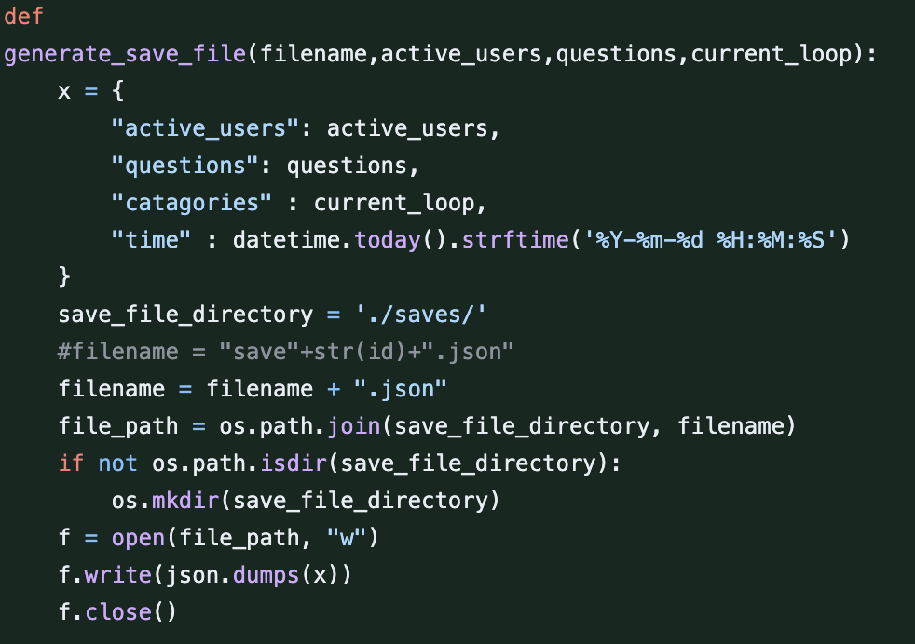

If you type save in the choice input in the quiz it will ask for a name, then save the users, questions and current loop values.

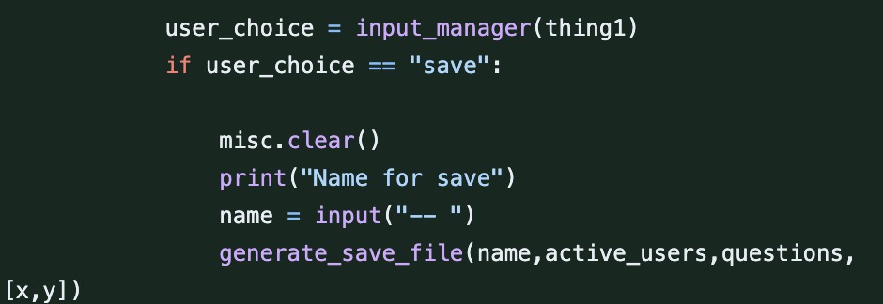

There is no way to load the save yet.

The question upper limit also works on any difficulty now.



## [Version 0.21.1](https://github.com/Puskalincer/yr13_python/commit/7b085030b0b9a114241086e238124304eb40b982)

Saved games can now be loaded and continued, a menu to display them neatly still needs to be made.

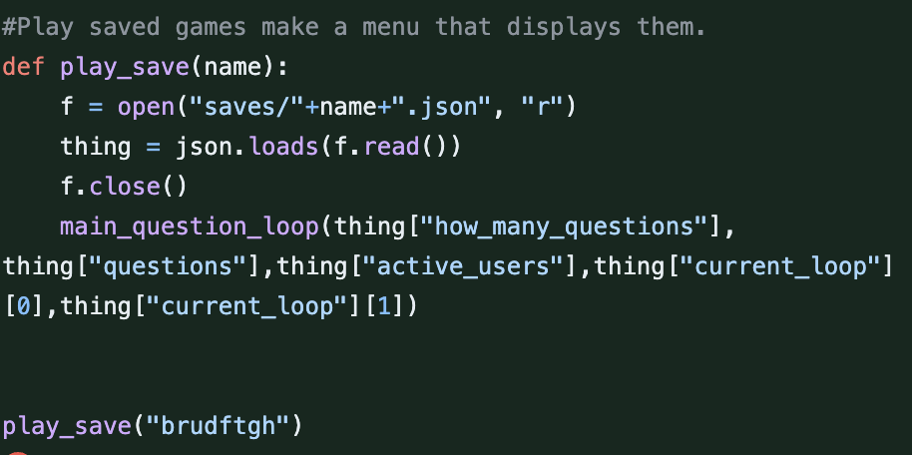

## [Version 0.21.2](https://github.com/Puskalincer/yr13_python/commit/9aed86ceb189b87830ede33f26fa1dafbe379a79) – saves work fully

There’s a continue button on the main menu now, and a nice menu to display saves.

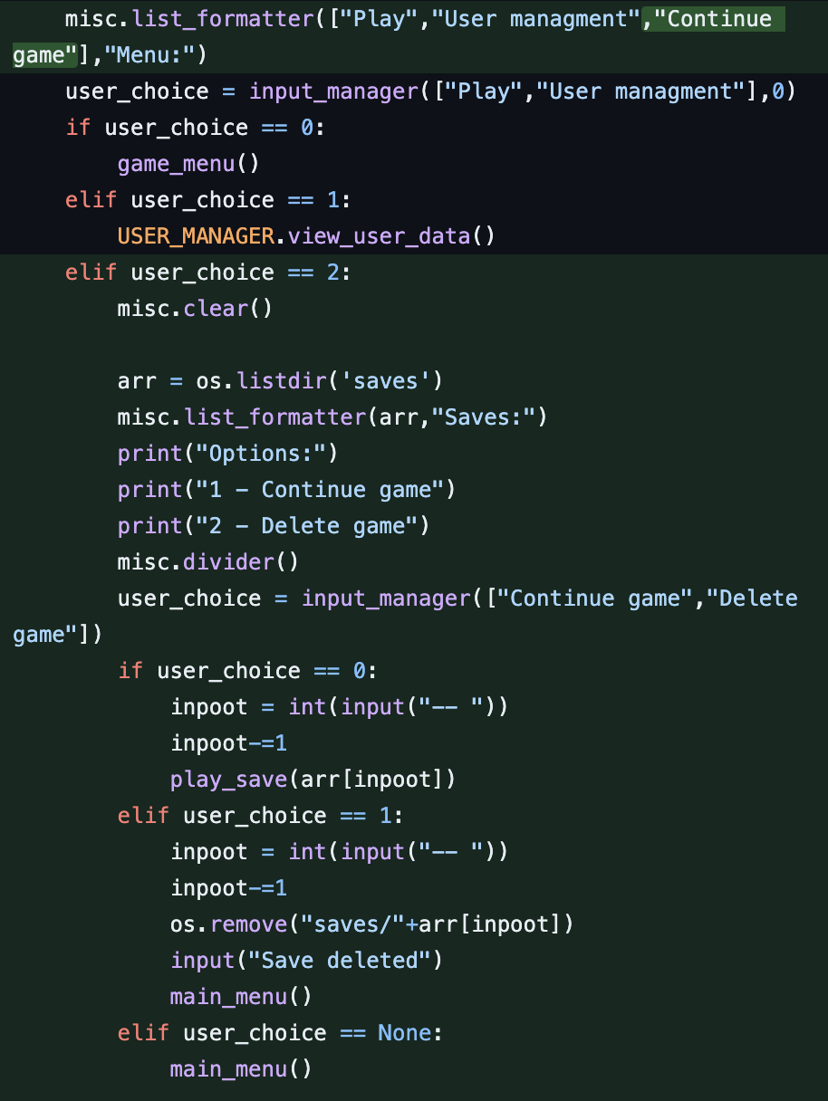 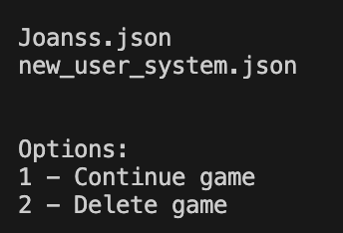

## [Version 0.22](https://github.com/Puskalincer/yr13_python/commit/8cba1fd72b7ea9f729a2e5e8effb855a008e0e70)

Put save menu in its own function instead of in main menu. Made new input function to replace old one. It works better.

## [Version 0.23](https://github.com/Puskalincer/yr13_python/commit/7f81d9f9cf7a17ea089d2e38c4096652ef1cbd72)

I found a cool module called flet and made another ui test. Its playable.

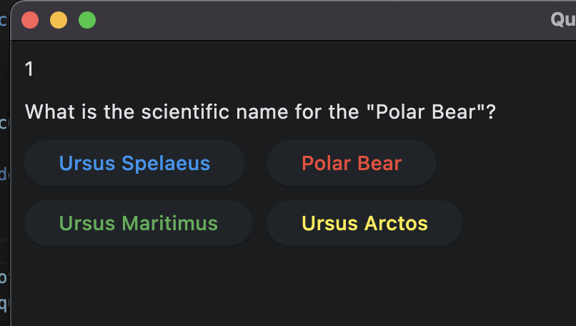

## [Version 0.23.1](https://github.com/Puskalincer/yr13_python/commit/c1e45a2351086a11c0cc29940d3a3d30b9f626c4)

More ui stuff.

## [Version 0.23.2](https://github.com/Puskalincer/yr13_python/commit/c80e6a1d885f969fc04bde9d0bd319da27ea630e)

Removed every instance of requests get and relaced them with a nice function that takes the string and an optional return key.

Old:



New:



Function:

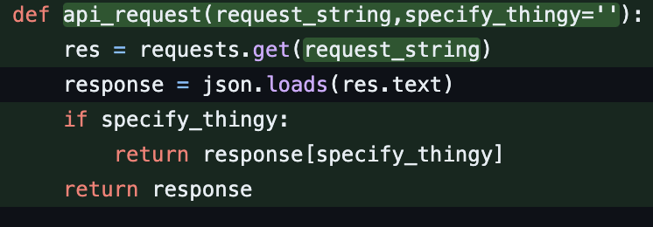

## [Version 0.24](https://github.com/Puskalincer/yr13_python/commit/51f7a2b74b0189e456221d6ffe4a0999aef4a4f3)

Removed unnecessary functions. Moved all function in separate files back into main.

Online status prints on the main menu for testing.



If offline you cant play custom games.

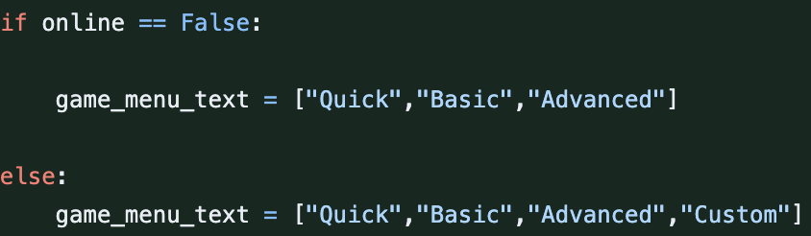

## [Version 0.24.1](https://github.com/Puskalincer/yr13_python/commit/9178416eb26f06851bac6d8d4dda76c1999eaeea)

Combined all printing related functions into the renderer class.

Changed the prints in the save menu to use the renderer.

## [Version 0.25](https://github.com/Puskalincer/yr13_python/commit/ff8a799a3afa515cadb3d39074f0c78a84f6e59b)

All list formatter function use changed to renderer.

Built skip function call into input function, removes need for if output = none call skip function after input.

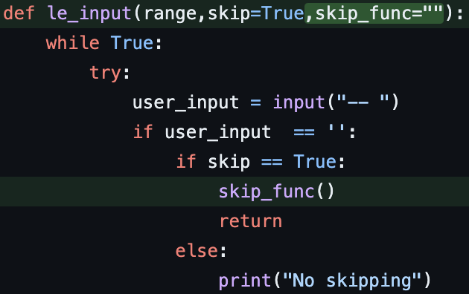

## [Version 0.25.1](https://github.com/Puskalincer/yr13_python/commit/2236f8a84255c88c0e324841d7f6a679038983c6)

Fully removed input manager and input manager 2 in favor of le input.

Added basic string management to input function.

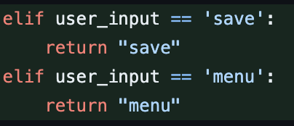

## [Version 0.26](https://github.com/Puskalincer/yr13_python/commit/73ef0fc828aa45485e8f0a414303ed3ffc7b01c6)

Tested encoding data as I could have saved data, game saves and questions encrypted for security. Due to the application of this program, I don’t think I’ll implement it. The teaching ability of having human readable info in the files is much more valuable.

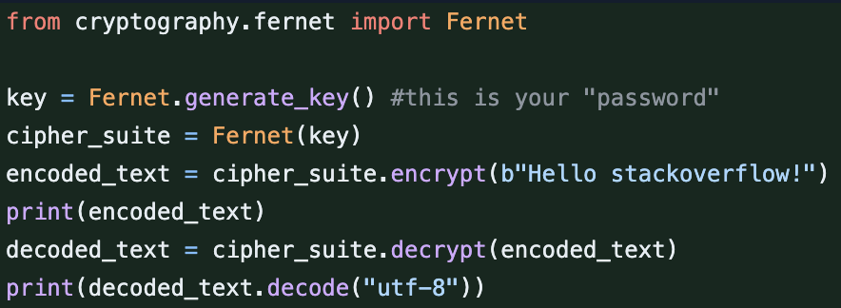

## [Version 0.27](https://github.com/Puskalincer/yr13_python/commit/bd50b0fa559af9b913f6670f8ace3bb0ebd35e93)

Nothing

## [Version 0.27.1](https://github.com/Puskalincer/yr13_python/commit/cc494ff7733ef4fb4e67c1fd91a61cbfff5cef32)

Minor organization on entire program.

## [Version 0.27.2](https://github.com/Puskalincer/yr13_python/commit/cc278727c914a5199eac11eaeb7dc7f6a6f9f25a)

Simplified automatic data manager.

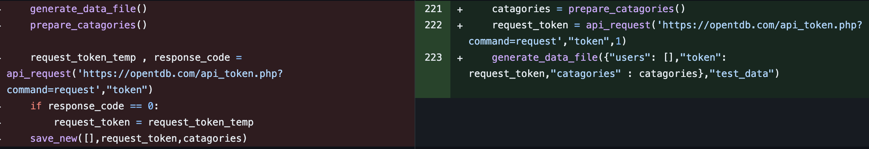

Changed variable names to match use.

## [Version 0.27.3](https://github.com/Puskalincer/yr13_python/commit/5404c5a38460afdd0888ef9a4802a5a9bb1cd1a8)

Moved offline question refresh counter from questions file to data file.

## [Version 0.27.4](https://github.com/Puskalincer/yr13_python/commit/0a65494fdff51cc52805be70dd4030c1d441fa6d)

Test version that was being done replaced old main.

## [Version 0.28](https://github.com/Puskalincer/yr13_python/commit/5a376325fa19ac9c2d566e16603ada3b8ef104c4) - bug

I changed a variable name for the save file from how many question to question amount. In playing the old saves they would break the code. I fixed this by change the variable name in the old saves, they then loaded and worked.

## [Version 0.28.1](https://github.com/Puskalincer/yr13_python/commit/f53e5c9cb82e7b7e2d554c0bd4fb704b04d68160)

New server and client tests made. A client can connect and play the quiz, I still need to figure out how to make 2 clients able to play.

## [Version 0.28.2](https://github.com/Puskalincer/yr13_python/commit/bf05cda079a27aacdf2cd60a01cf92bcd3598dad)

More attempts and failings to get multiplayer working.

## [Version 0.29](https://github.com/Puskalincer/yr13_python/commit/01bfa13c95dbdd31d06f7c978ad85deac9c2e444) – new stuff

New module gotten called [py_boxen](https://github.com/savioxavier/pyboxen).

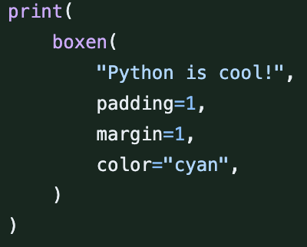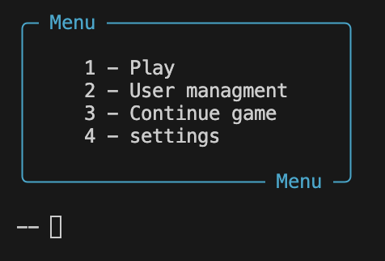

It prints the menus in a really cool way and I updated the renderer to change all the menus to cool menu.

## [Version 0.29.1](https://github.com/Puskalincer/yr13_python/commit/0822366a56d010b20bc908ab4b91a0bcf2cfcb93)

Minor changes.

## [Version 0.29.2](https://github.com/Puskalincer/yr13_python/commit/d3c8d6ed321731cc1a3d8792eaaf791cba361a7d)

Fully implemented new menu as it wasn’t used on some menus.

## [Version 0.30](https://github.com/Puskalincer/yr13_python/commit/9d230443a8b162525763c038e6c8ae12b840ebae)

Main question loop now has scoring.

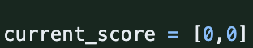

The score storage is hard codded for 2 users, I will change later.

There’s also a timer on the input to see how long you take, this may not be used.

## [Version 0.30.1](https://github.com/Puskalincer/yr13_python/commit/3215f2e4417e64d79ebcb48067ba1eef18d0d220)

The score is calculated using these values.

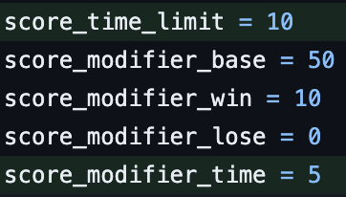 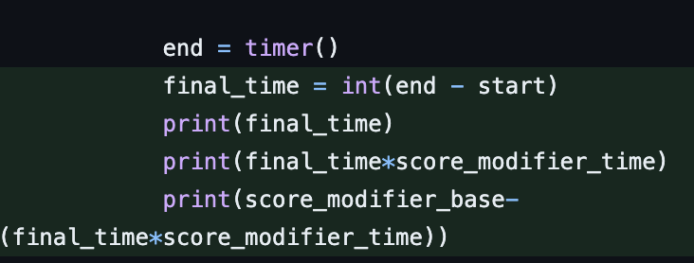

## [Version 0.30.2](https://github.com/Puskalincer/yr13_python/commit/559098d9ae43efcdcac19076e53252eb87cbdbc1)

Finally got eel working and made a basic webpage display.

## [Version 0.31](https://github.com/Puskalincer/yr13_python/commit/b360f7ddc89d126cf07ef562c3505f5c45b7d187)

New ui in the making.

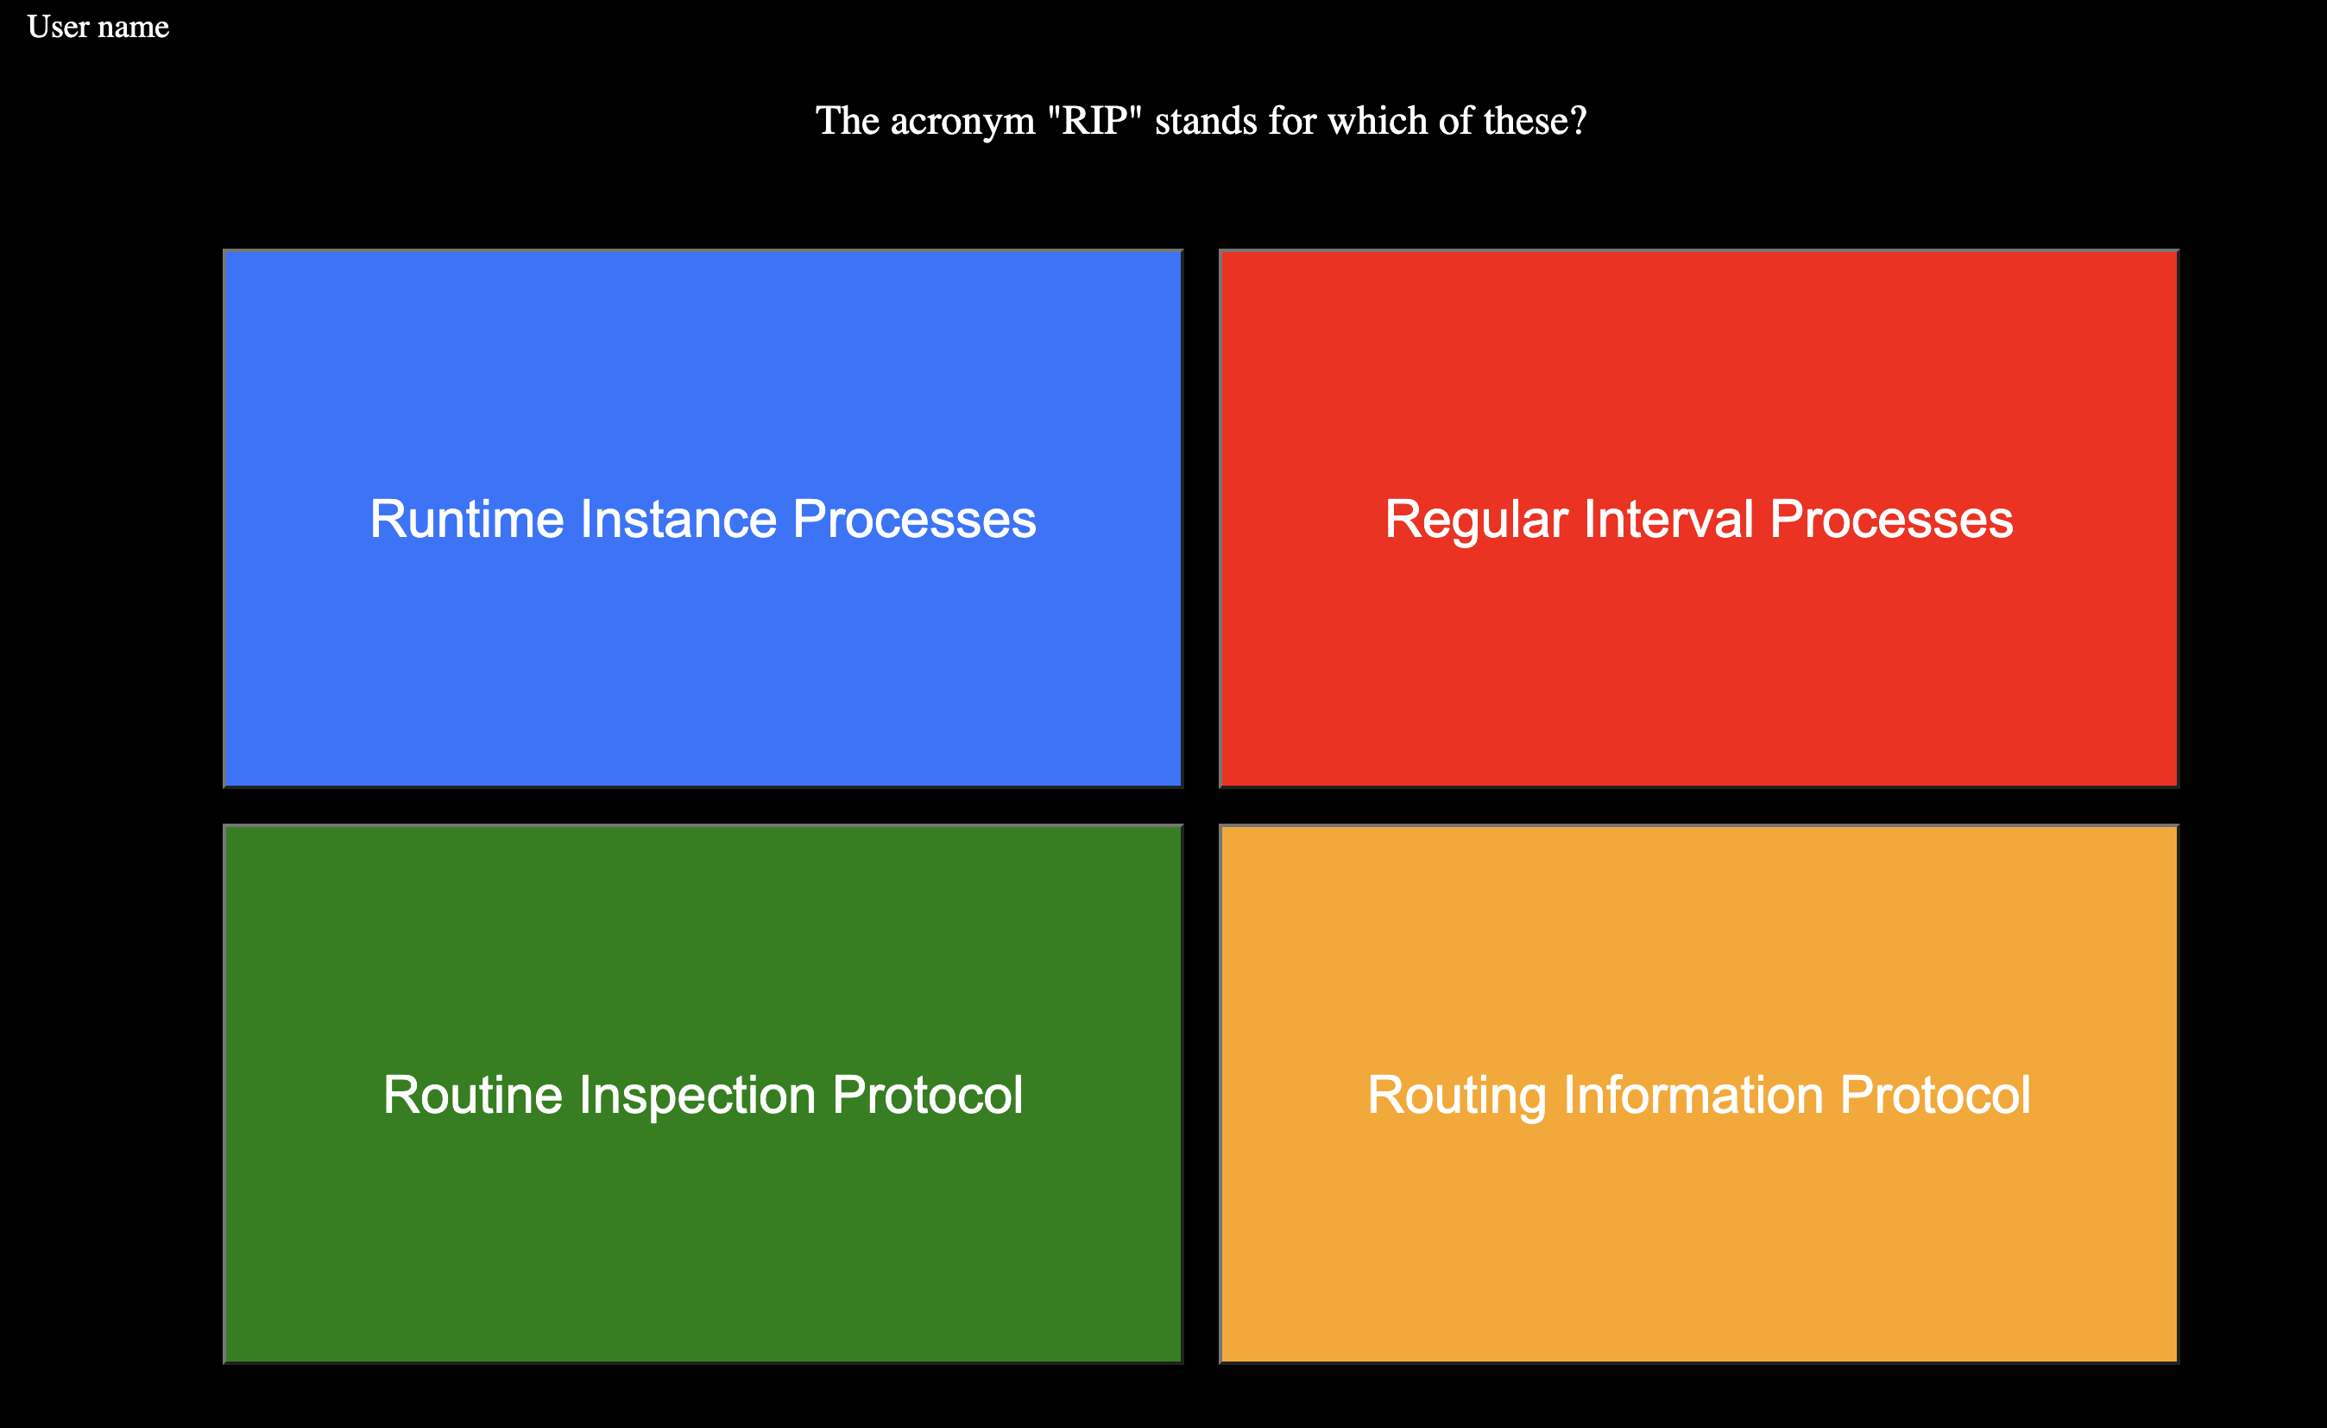

## [Version 0.31.1](https://github.com/Puskalincer/yr13_python/commit/7fbc75440bd7854aeb98e996564442d09d4aed6a)

The timer on the question should stop you from inputting after it reaches 0, but couldn’t quite figure out how to do that.

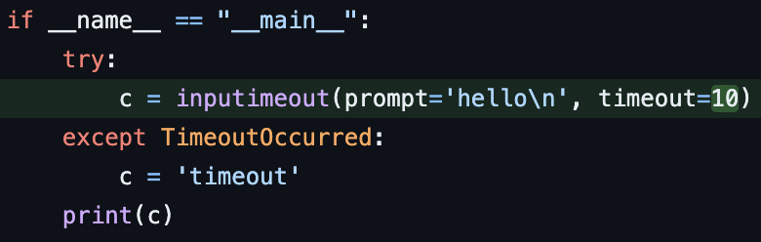

The ui’s logic was also made.

## [Version 0.31.2](https://github.com/Puskalincer/yr13_python/commit/2278c170b7fc45a4ea1fff540182a42ba11fed7a)

When saving a game the user will be shown the existing saves. If they use an existing name they will be asked to override the save.

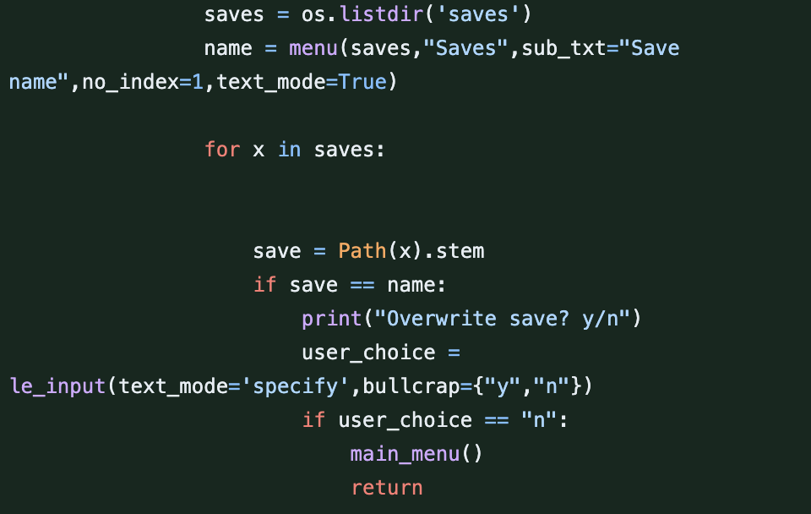

## [Version 0.31.3](https://github.com/Puskalincer/yr13_python/commit/2345e35a62ef0d81e6d0c83a14c14931383ce4ec)

Save folder auto generates if it doesn’t exist.

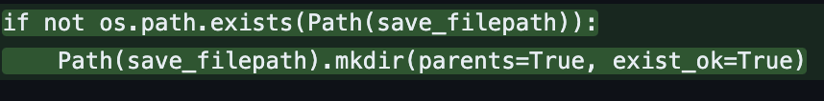

If there are no saves it will say no saves and not display options.

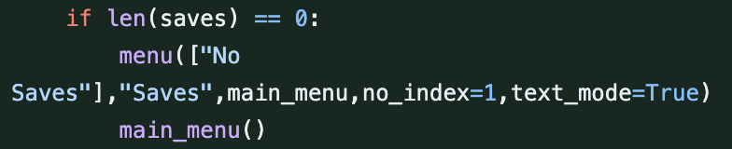

## [Version 0.31.4](https://github.com/Puskalincer/yr13_python/commit/cecac8eba3c2df380389e044b9e6b9c64cfd2b9c)

More ui logic was made.

## [Version 0.31.5](https://github.com/Puskalincer/yr13_python/commit/7fddb9b216b891f6e1754f1a4714ff8047e8006d)

Put ability to choose either type back in as it was removed a while ago.

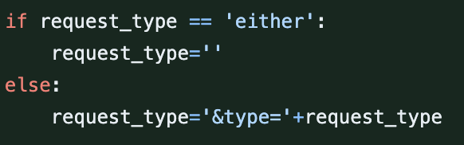

More ui stuff.

## Version 0.32-0.35

Lots of ui stuff culminating in a usable but not perfect quiz. Video in folder.

## [Version 0.36](https://github.com/Puskalincer/yr13_python/commit/6703a82024a98909c212ccbd1328bd85ffd30ed8)

Made ui menu system to use as well.

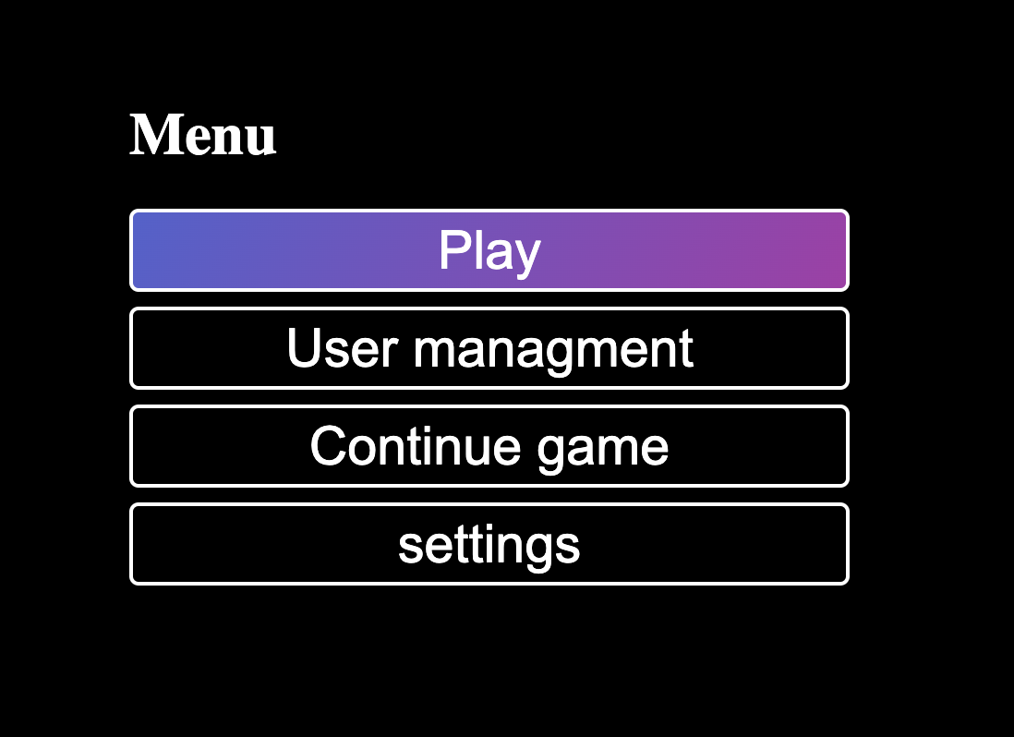

## [Version 0.36.1](https://github.com/Puskalincer/yr13_python/commit/38f3663b5764dc0ff0d3be6cc1a99a93f626e3a6)

Replaced my complicated array untangle function for simpler one liner.

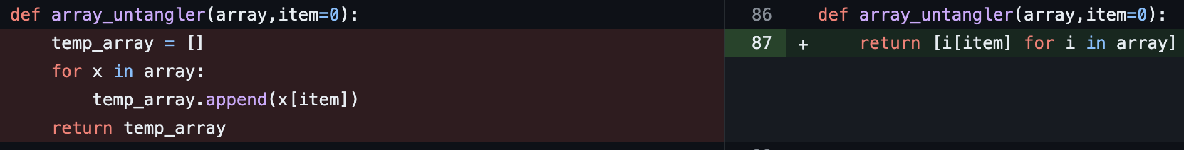

The quiz api has a max of 50 but the category limit request can result in a number higher than 50. If that’s the case have it print the max as 50.

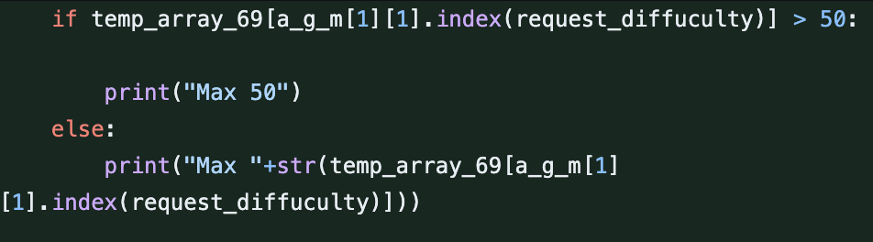

brought any difficulty functionality back.

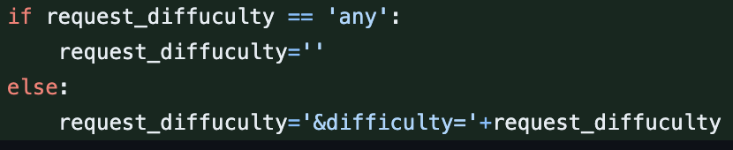

## [Version 0.37](https://github.com/Puskalincer/yr13_python/commit/9353a3b5be347e475eada842132d004e59a5479d)

Made user class and user management class. Each user is an. Object instance of this class.

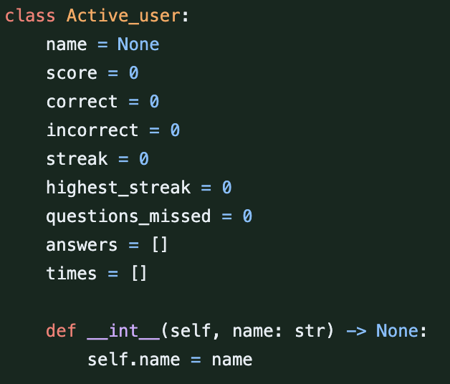

This classes function and array are used in the quiz.

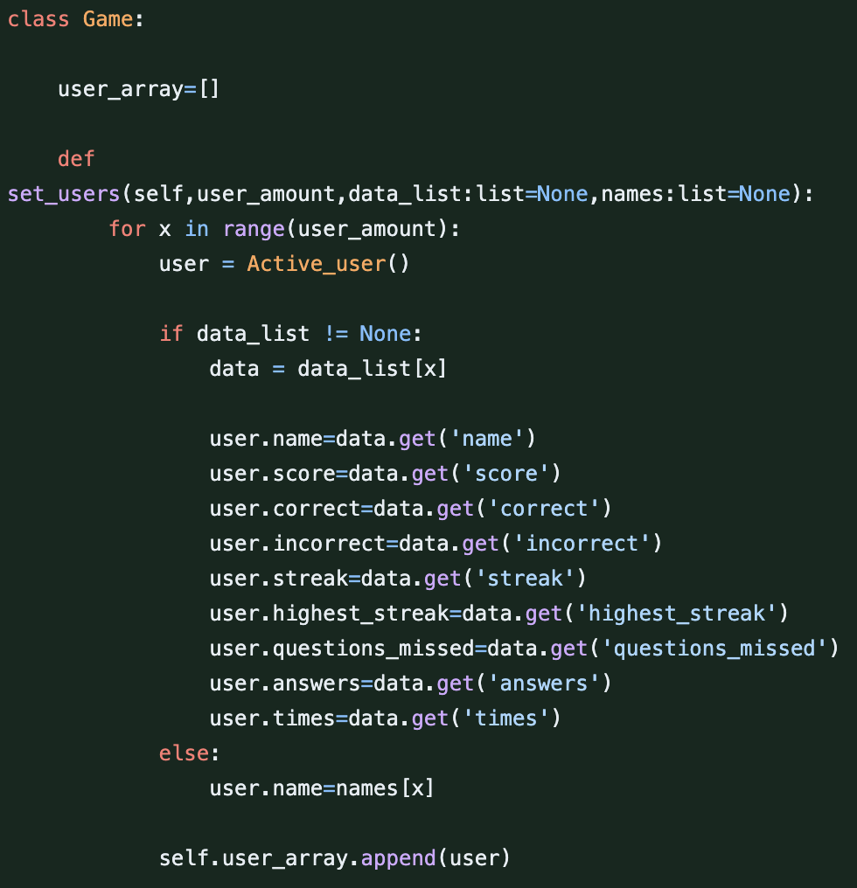

I set the user amount and data from saved data; this is then used in the quiz loop.

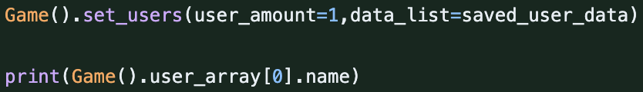

I will have to rework game saves and user saves to integrate classes fully.

## [Version 0.37.1](https://github.com/Puskalincer/yr13_python/commit/fc572f5d9700cd58a9ea4c84930ca4c51af4ae07)

Removed user amount parameter in set users function.

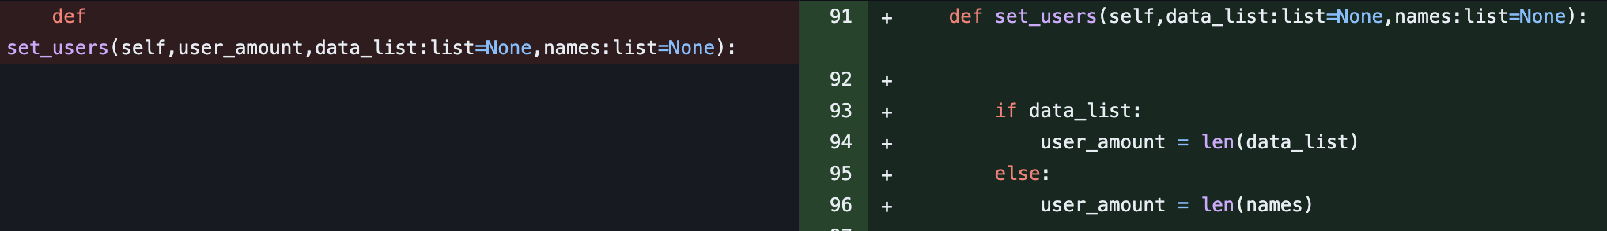

Made function that exports the user objects as dictionary’s to be saved in file. With this function I can use the exported users in the save file. The existing prepare function takes the existing user dictionary and makes them back into objects.

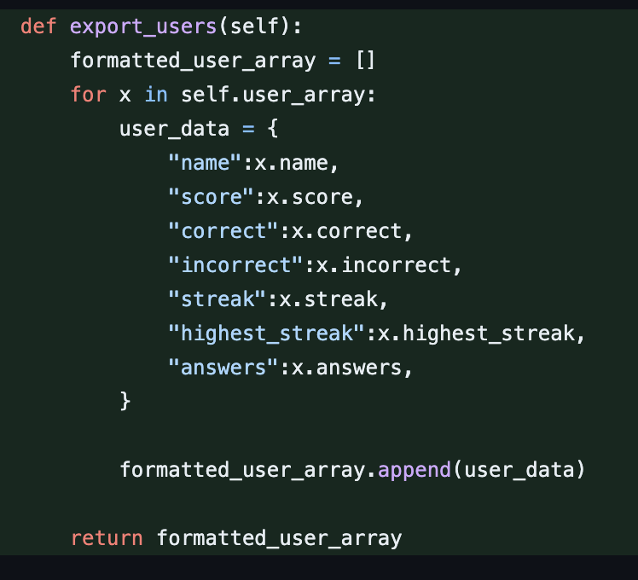

Print the final scores .

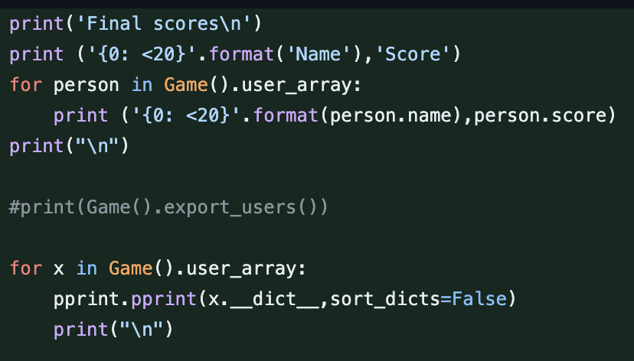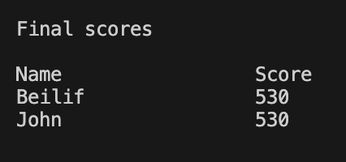

## [Version 0.37.2](https://github.com/Puskalincer/yr13_python/commit/8e6ed06747838c2d2fbf4e385bdc651e5a1370ea)

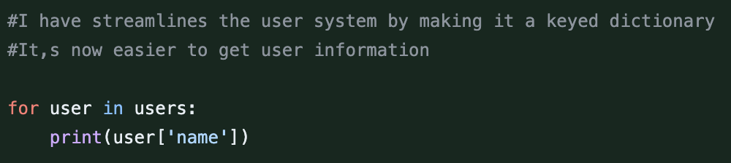

## Version 0.38

The user format has now changed to include each game that user has played. It also has name and high score that it displays in user manager.

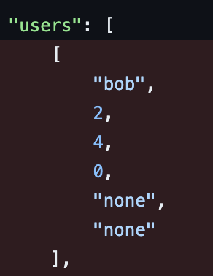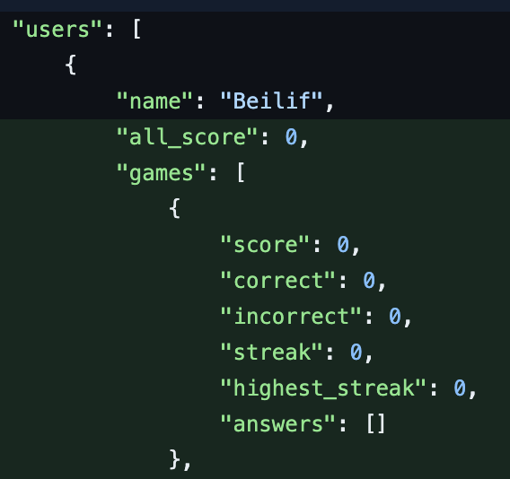

New user data menu made. This hasn’t worked for many versions.

New user format was also changed to work properly and delete user had the pin stuff removed as users don’t have pins anymore.

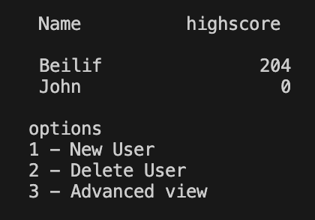 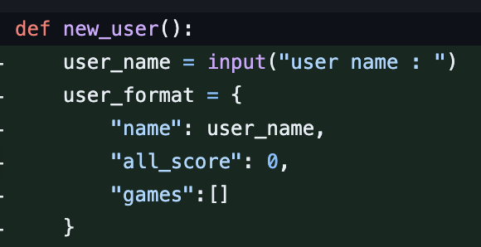

Format the user data and each game in a readable form.

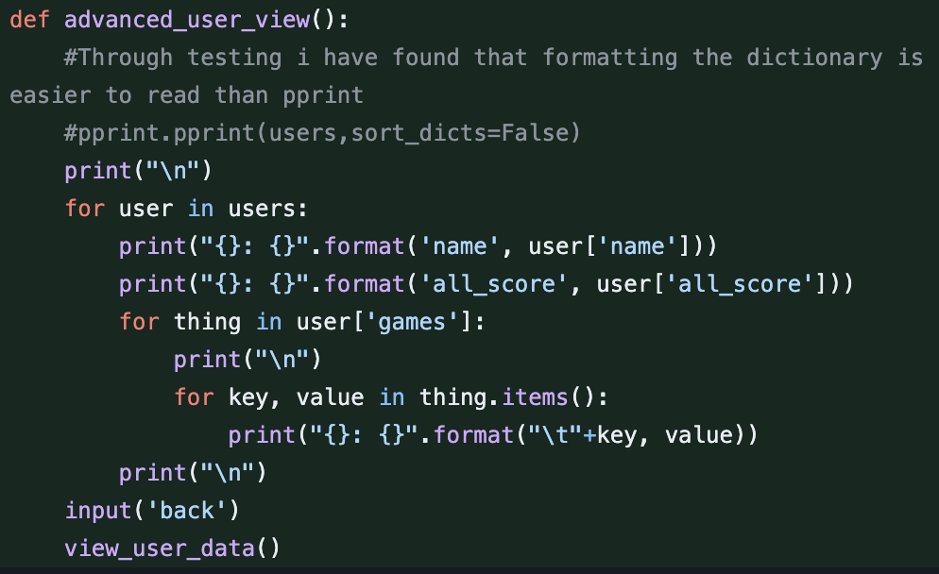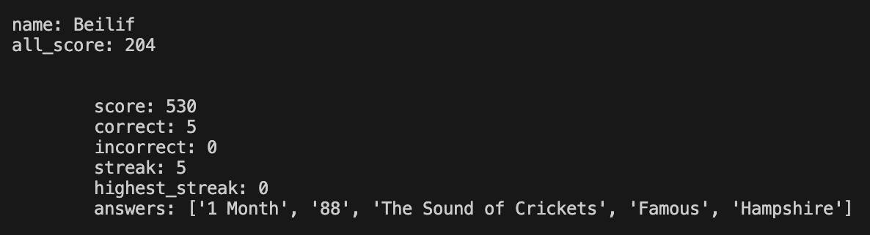

## [Version 0.38.1](https://github.com/Puskalincer/yr13_python/commit/cfe80356833790b18024f795265ad2c260a10e0e)

Made file read function. Replaced instances of reading file with this function.

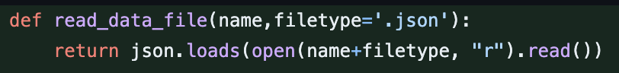

Fully implemented new user class system, depreciated old main quiz and quiz prepare functions.

## [Version 0.39](https://github.com/Puskalincer/yr13_python/commit/5adb6ad3456552ecfb7083a5b393dc034b7dda5d)

Add users game data to their users data in the file by comparing name and getting index then appending.

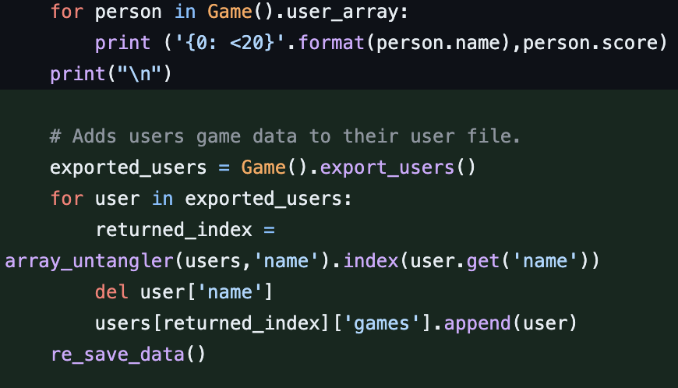

Removed old main quiz, quiz prepare and their respective variables.

## [Version 0.39.1](https://github.com/Puskalincer/yr13_python/commit/977f7b9092e155add1389d5e8048e4ee785ed6cb)

Data and question file is now saved in a folder, if the folder doesn’t exist it makes one.

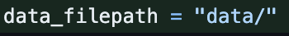

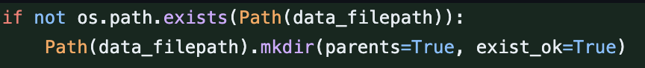

Made a better error message when advanced game fails.



## [Version 0.39.2](https://github.com/Puskalincer/yr13_python/commit/2ab55dcb408b00cba4ef225f693cfd95dedfcfdb)

Bug

Any instance of the program trying to read data failed. It was because I forgot to add the folder path to the files the program was trying to load. 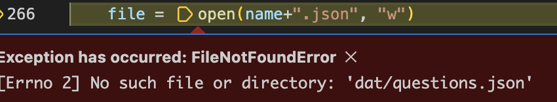

I fixed this by adding the folder to the start of all data file loading.

I also made a file to teach a classmate about how classes and objects work

## [Version 0.40](https://github.com/Puskalincer/yr13_python/commit/a06d09037b7a88d66763b3d7a028c2ff1675444e)

Bug

When the quiz finished and it added both users game results to the main users dictionary, both users had the exact same results. It seems that arrays in an object become linked.

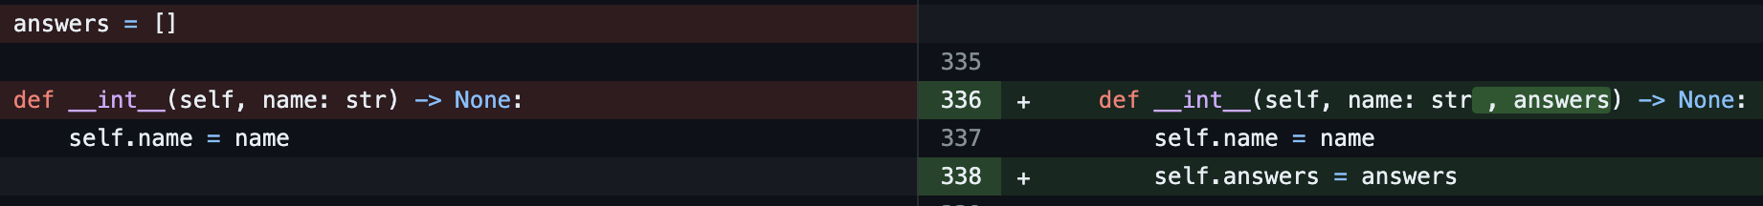

I fixed this by removing the answers array from the class and putting it in the int function.

Then when making the array of user objects set the array to empty, this solved the problem making each users game their own results.

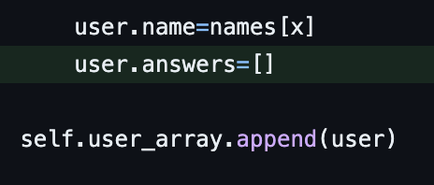

### Bug fix

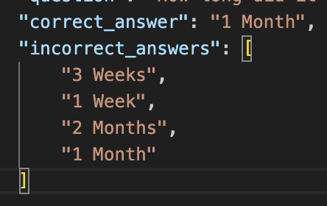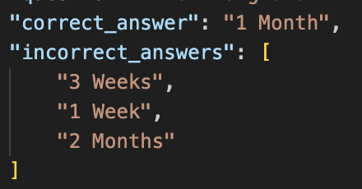

Each question has either 4 answers or 2. I had a problem where when a save is made the question you saved on ends up with 5 potential answers. I found that the problem was caused by this line.

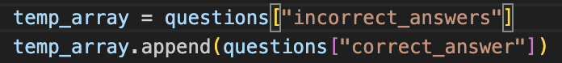

I thought that this would make the temp array variable have the same contents as the incorrect answers variable, it turns out it links them which is bad as I add the correct answer to the temp array. I fixed this issue by making a new array and adding the contents from incorrect answers to temp array. This fixed the issue as seen in the top left screenshot.



## Version 0.40.1

Bug

I kept getting this error as I was testing the automatic generation of required files. It took a while but I found the error.

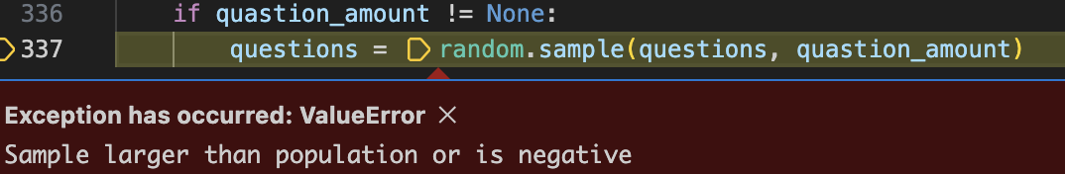

The automatically generated question file had the old counter in it. I removed the old counter and it worked.

